Western Mathematics Exams

School Name

Half Yearly Examination
2016
Year 10
Mathematics Course

Solutions
Year 10 |  | WME Solutions  Mathematics  Half Yearly | Non Calculator
Section 1 Short Answer Section
ANSWERS
No. | WORKING |  | ANSWER
 |  |  | 32
 | 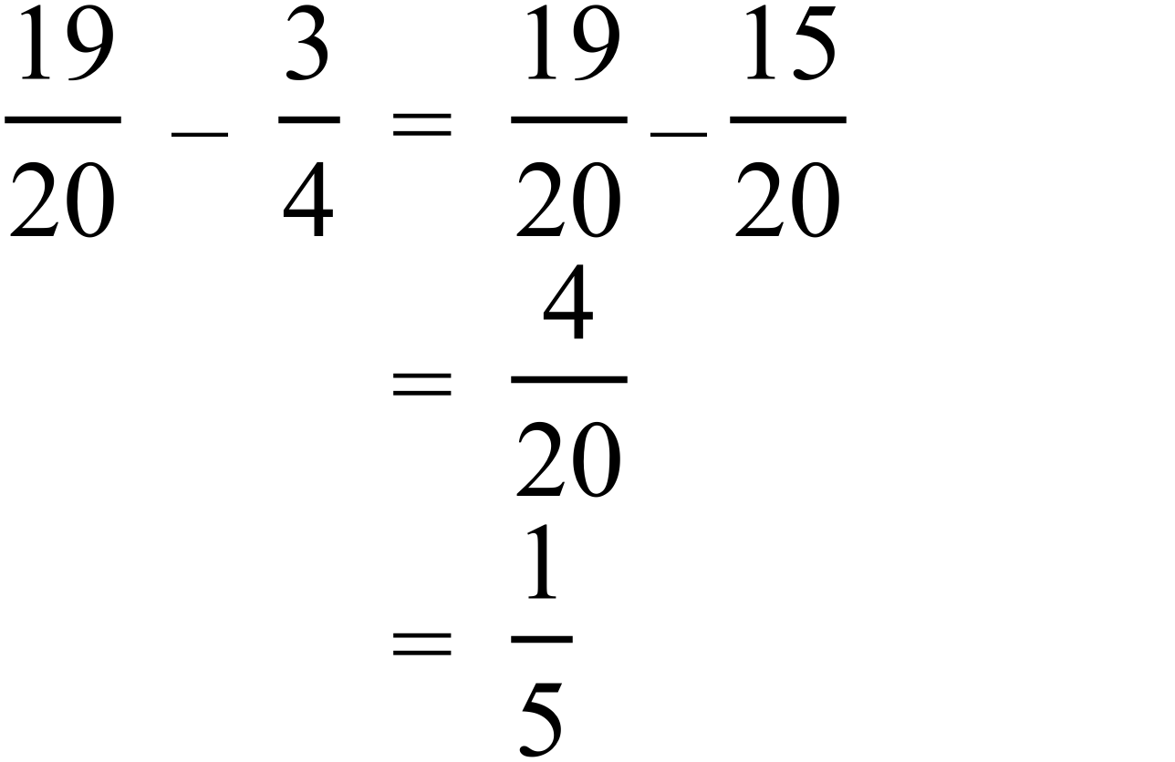 |  | 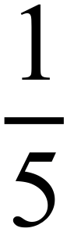
 | 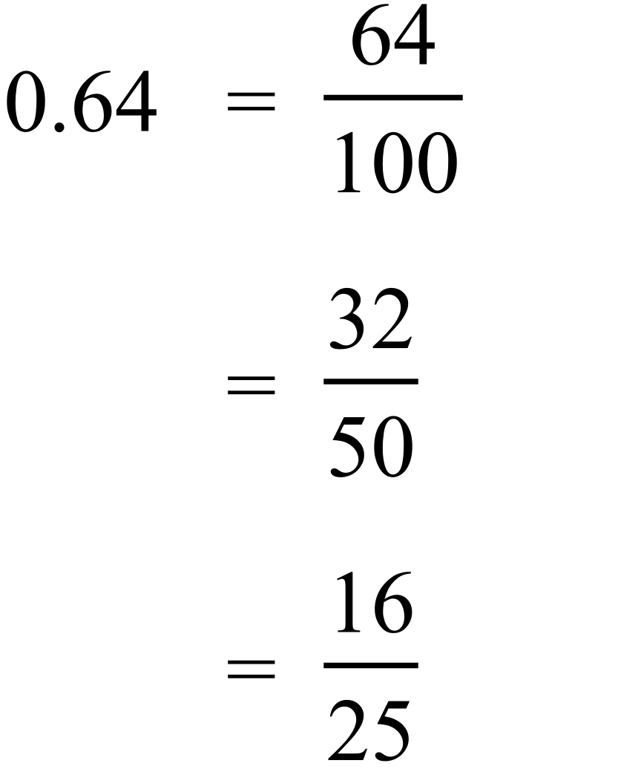 |  | 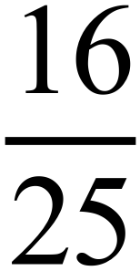
 | From 4 pm to 11 pm is 7 hours.  In 7 hours, the temp falls 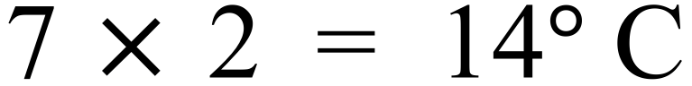  Temp at 11 pm = |  | 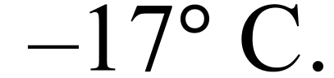
 | 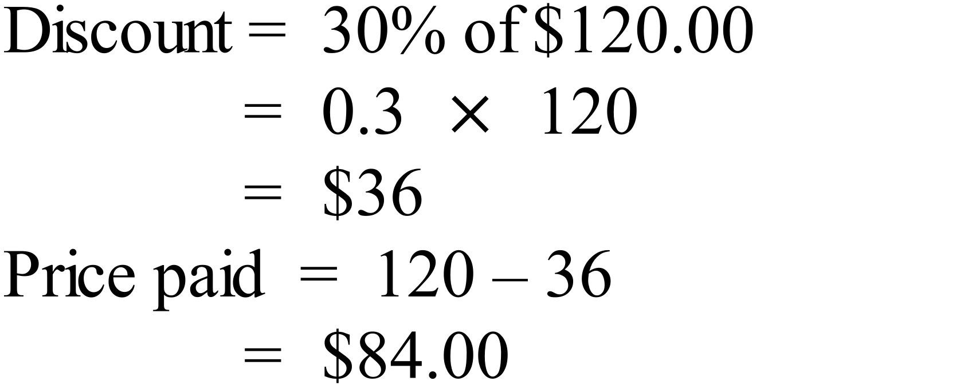 |  | $84.00
 | 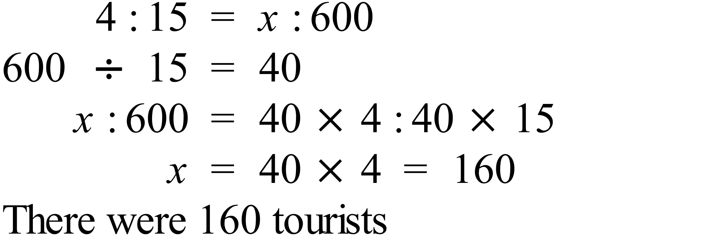 |  | 160 tourists
 | 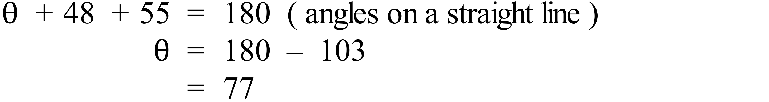 |  | 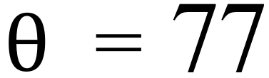
 | 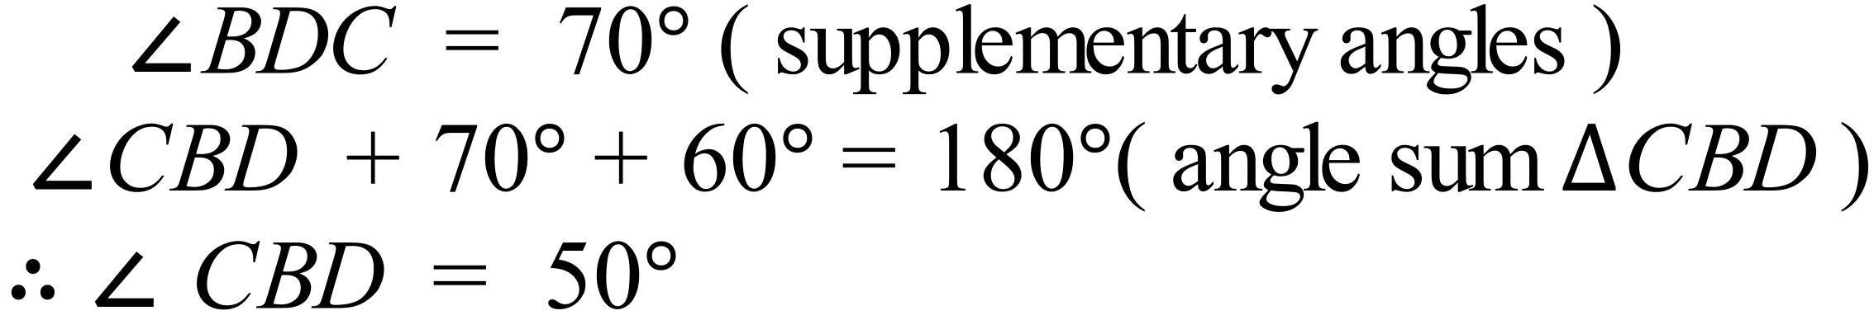  OR  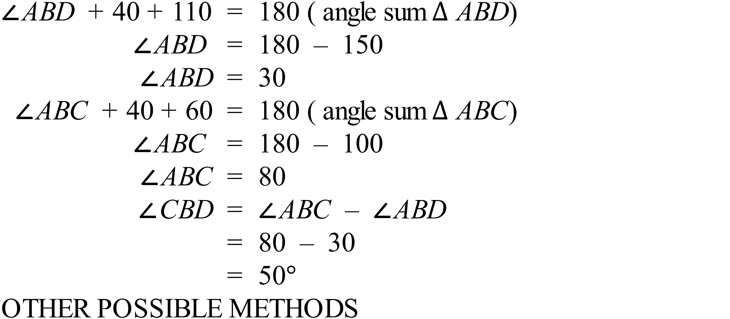 |  | 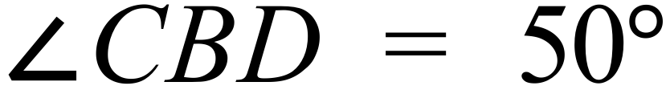
 | 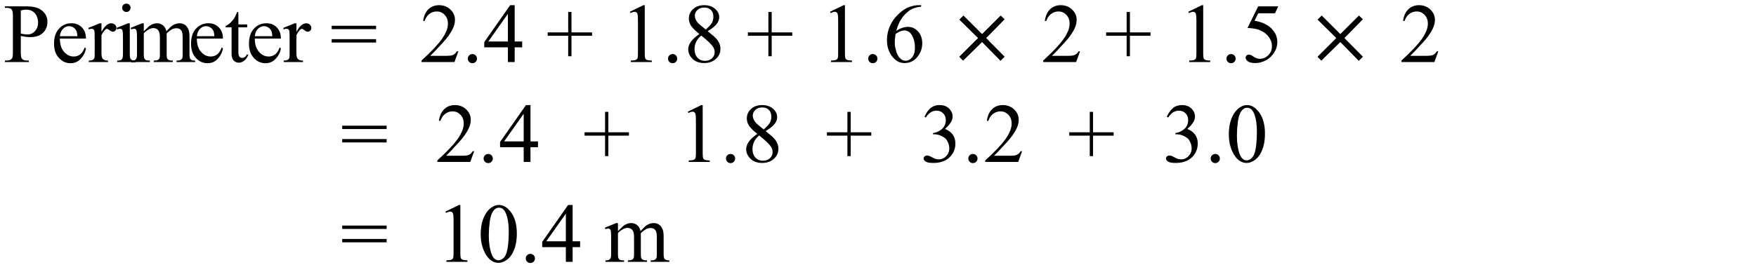 |  | 10.4 m
 | 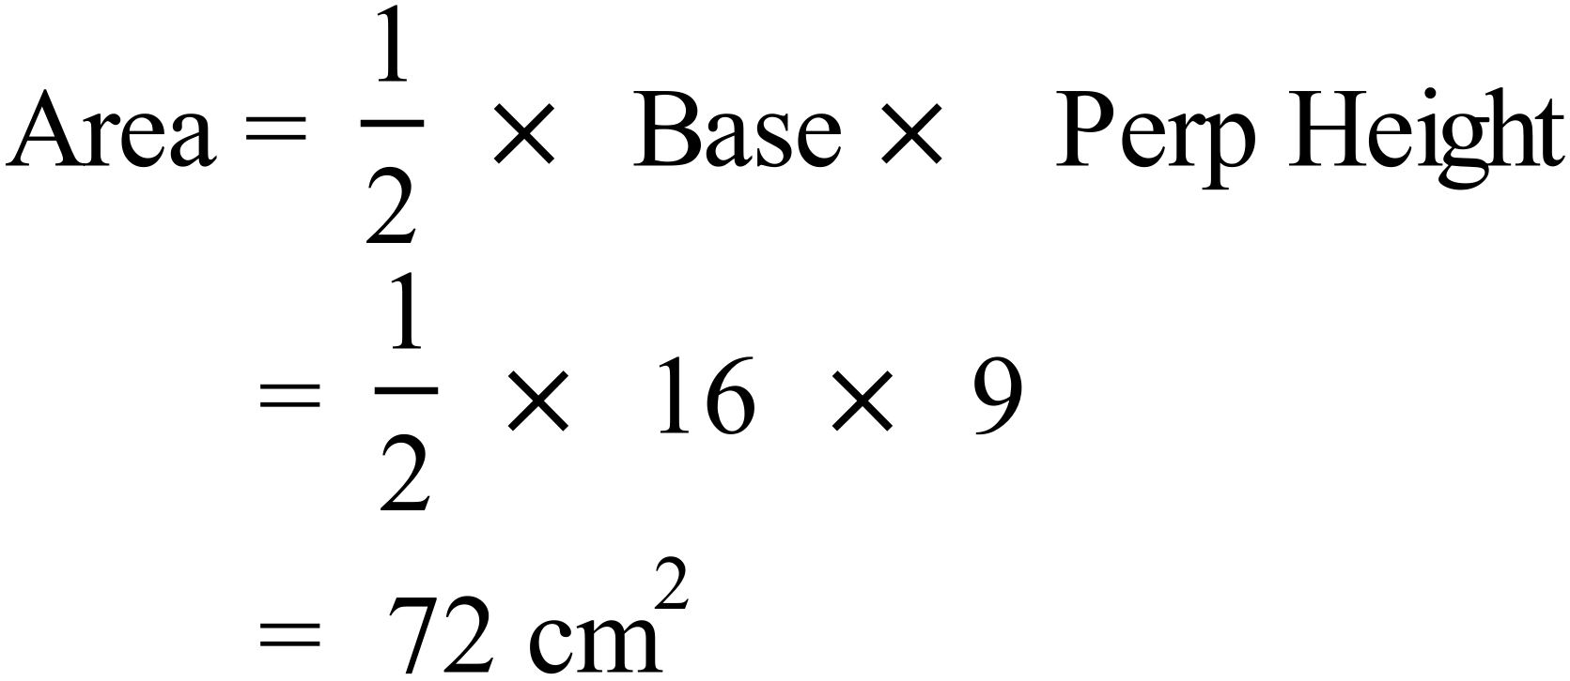 |  | 72 cm²
 | 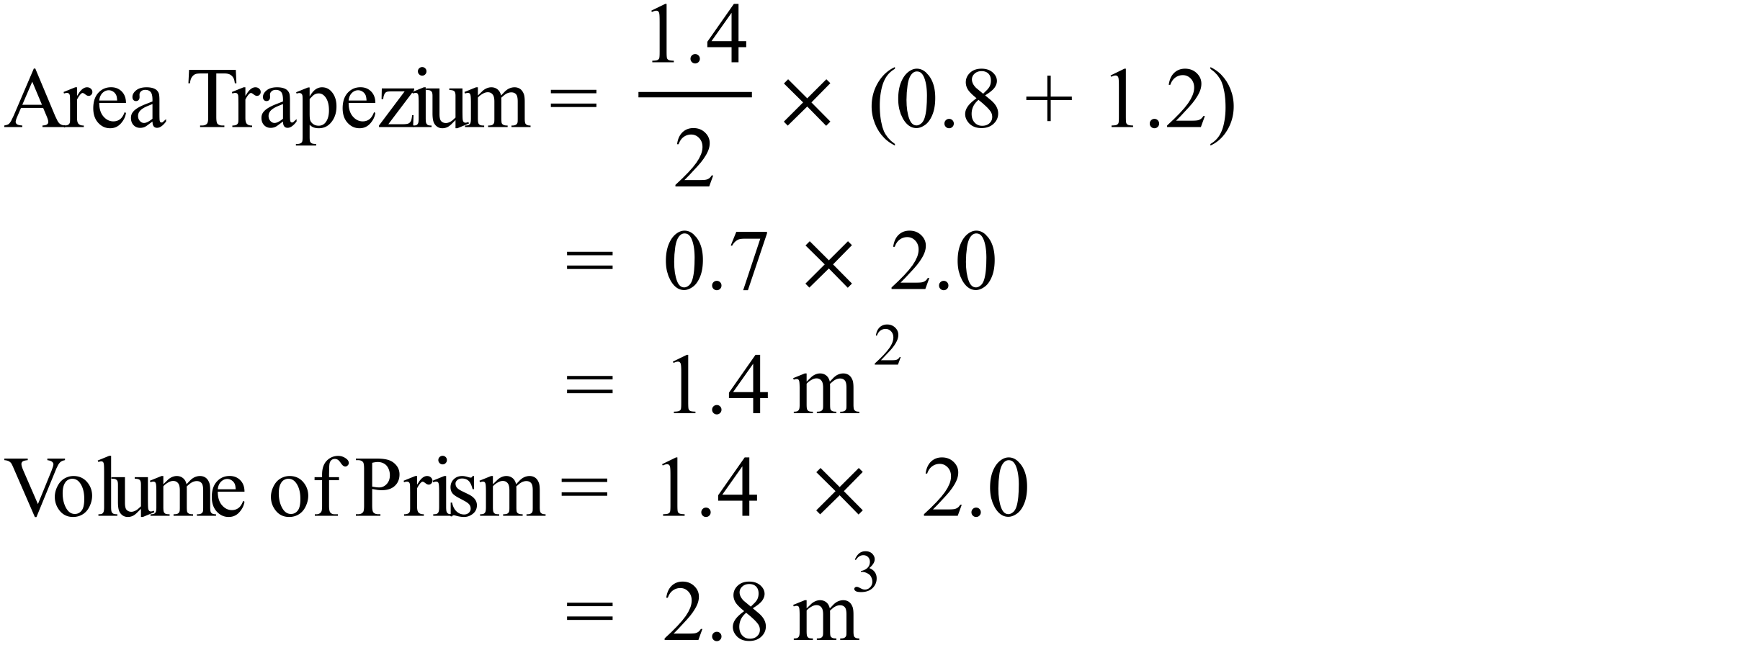 |  | 2.8 m³
 |  |  | 14xy
 | 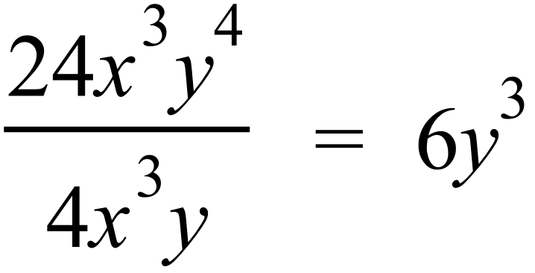 |  | 6y³
 | 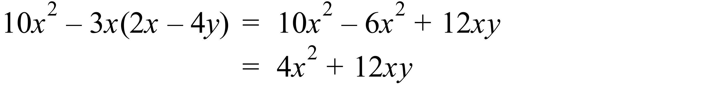 |  | 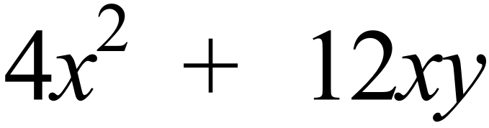
 | 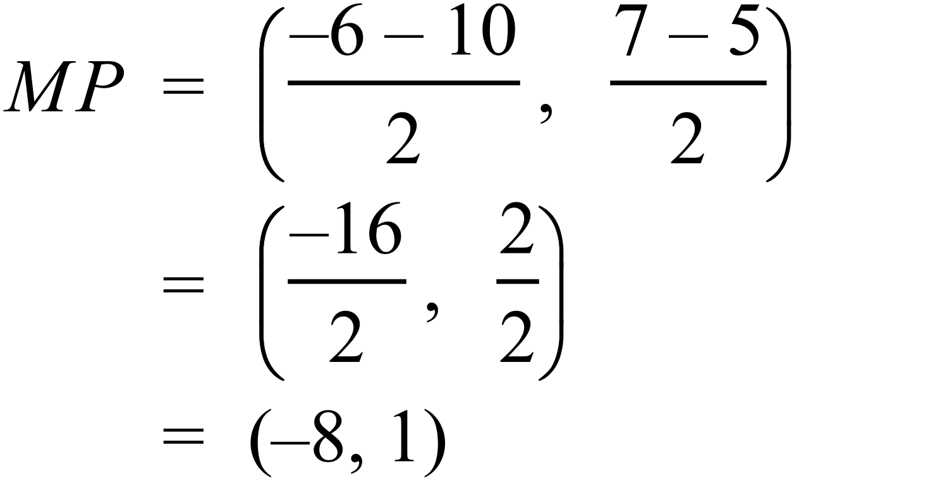 |  | (-8, 1)
 | 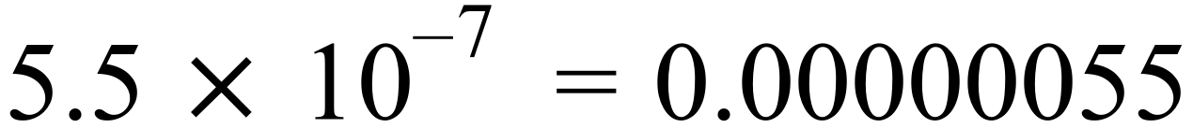 |  | 0.00000055 metres
 | 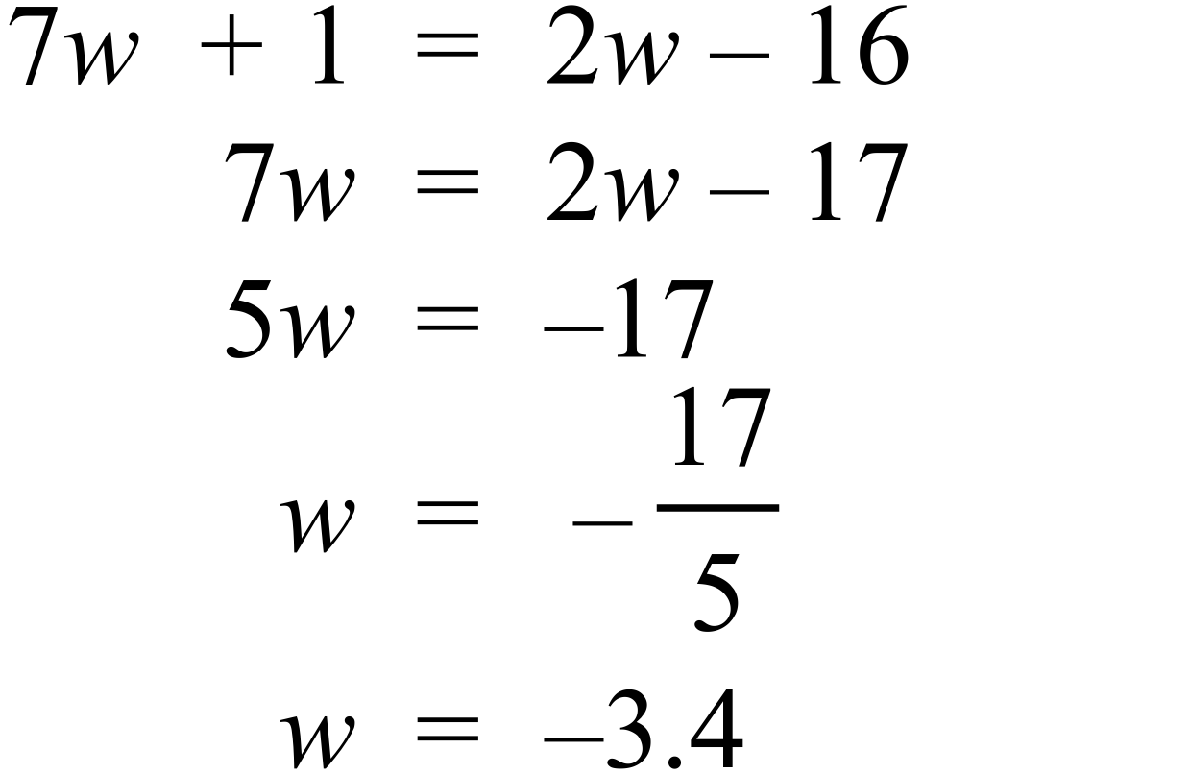 |  | 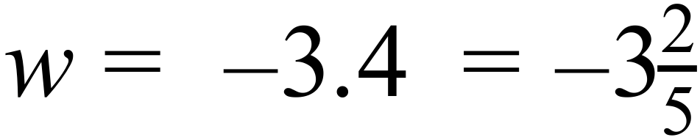
 | 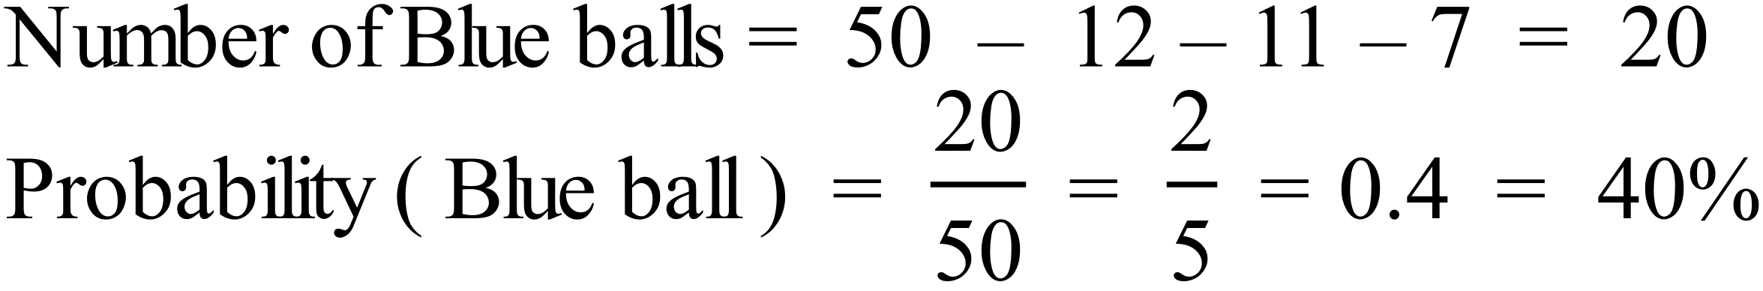 |  | Any of  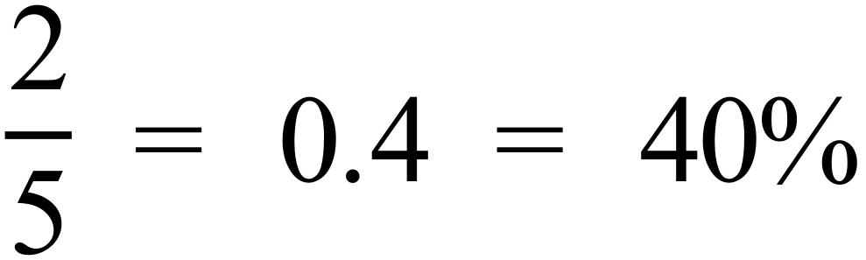
 | There are 7 scores out of 20 which are less than 20.  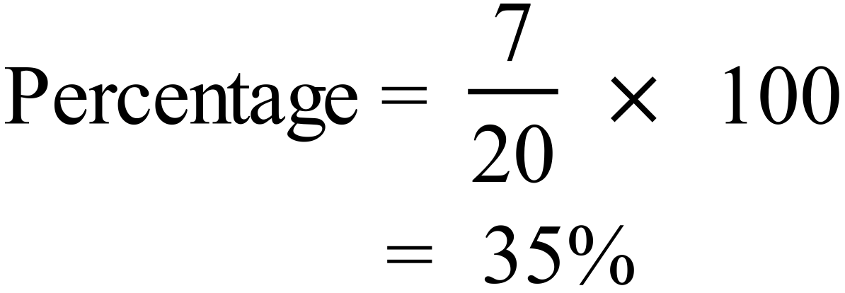 |  | 35%
 | Sum of the scores = 12 + 61 + 122 + 69 + 167 + 107  = 538  Mean = 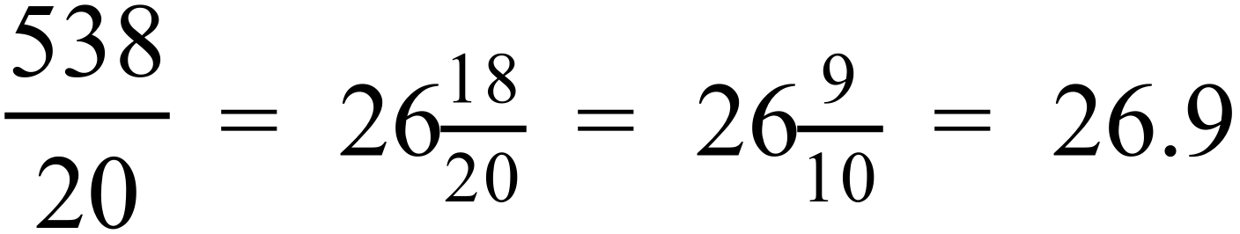 |  | 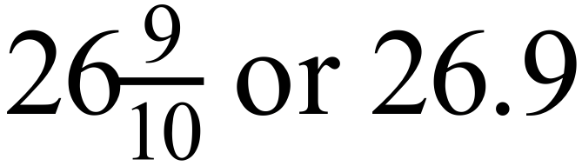

Year 10 |  | WME Solutions  Mathematics  Half Yearly | Calculator Allowed
Section 2 Part A Multiple Choice Section
ANSWERS
No. | WORKING |  |  | ANSWER
 | 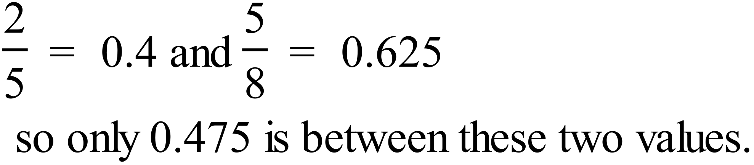 |  |  | C
 | 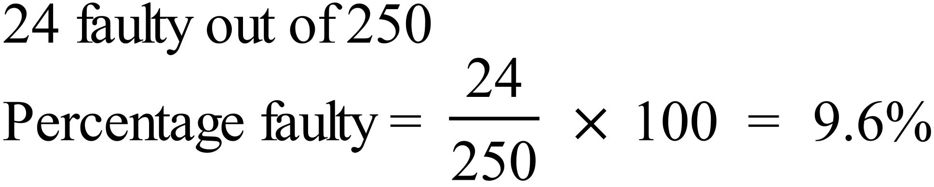 |  |  | B
 | 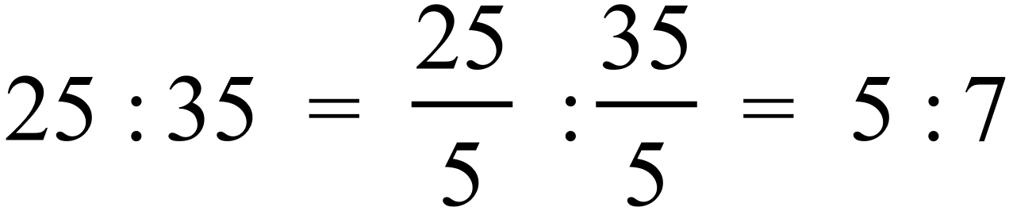 |  |  | A
 | 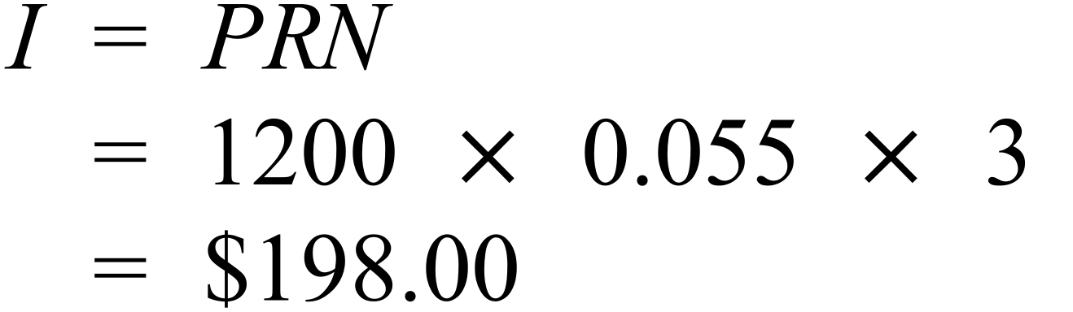 |  |  | D
 |  |  |  | A
 | 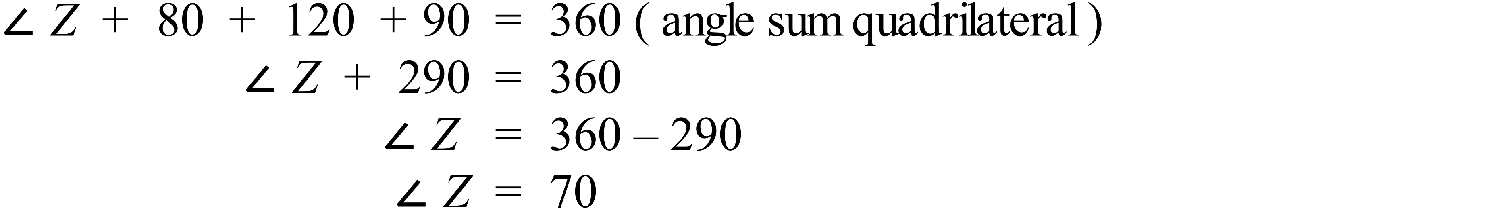 |  |  | C
 | 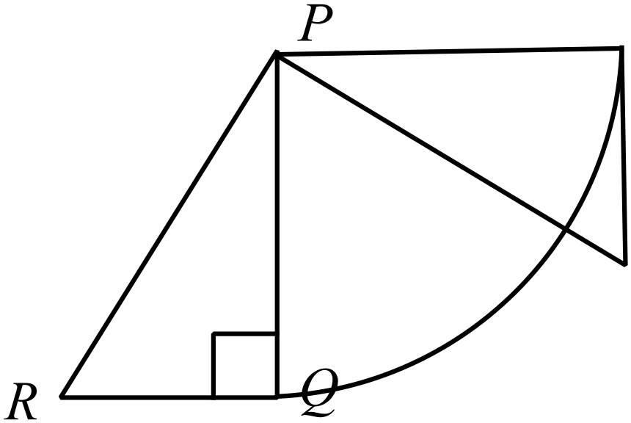 |  |  | D
 | 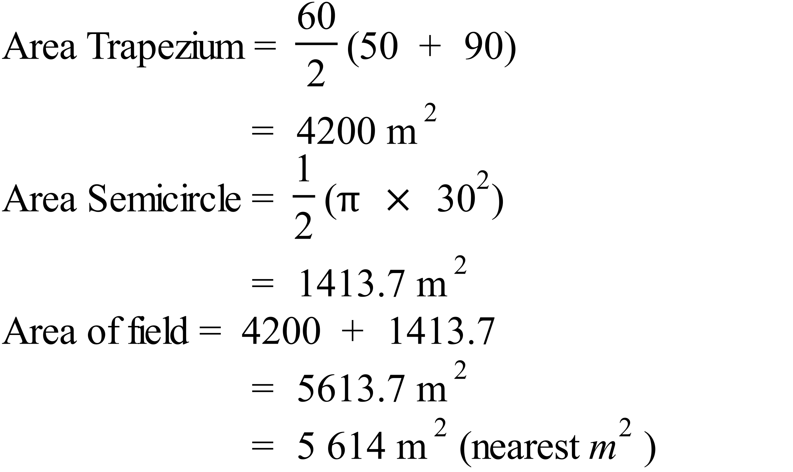 |  |  | B
 | 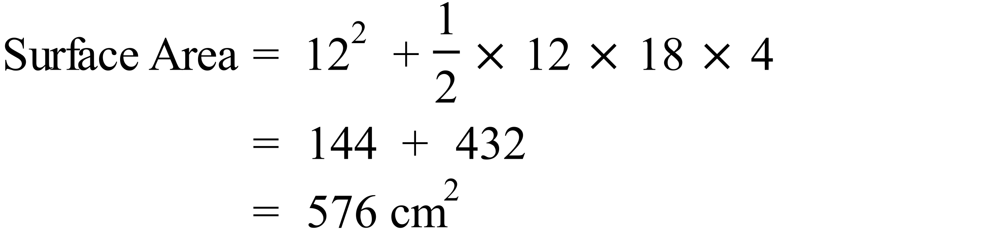 |  |  | A
 | 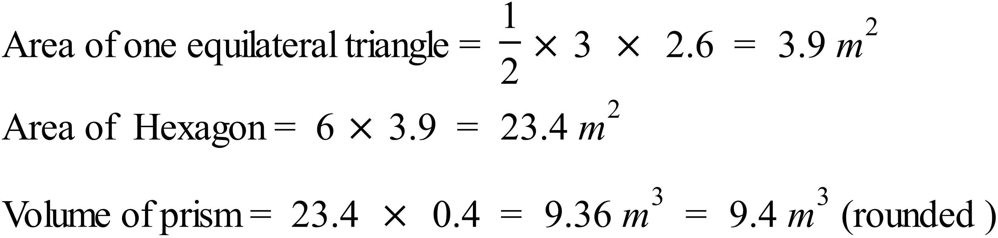 |  |  | C
 | 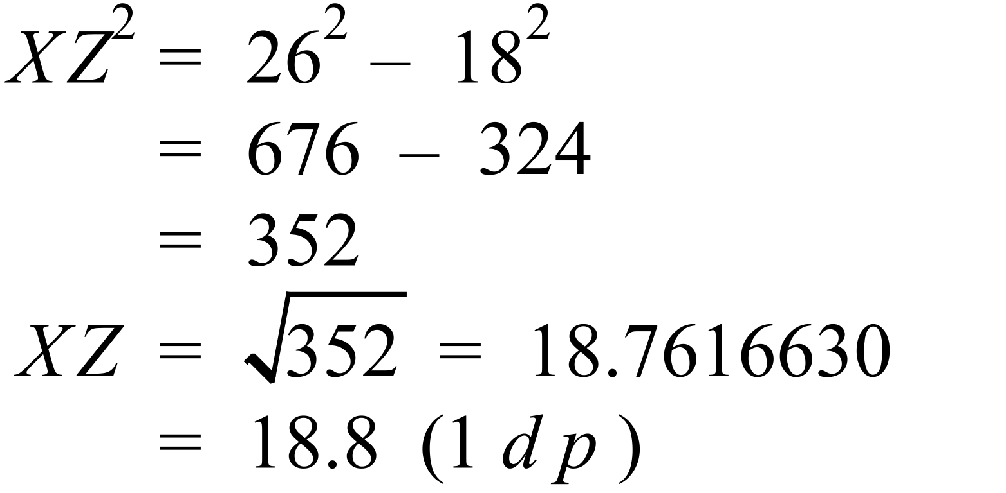 |  |  | B
 | 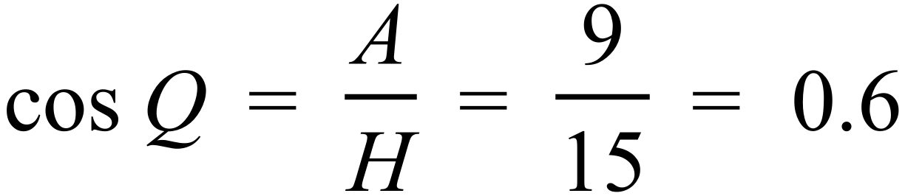 |  |  | A
 | 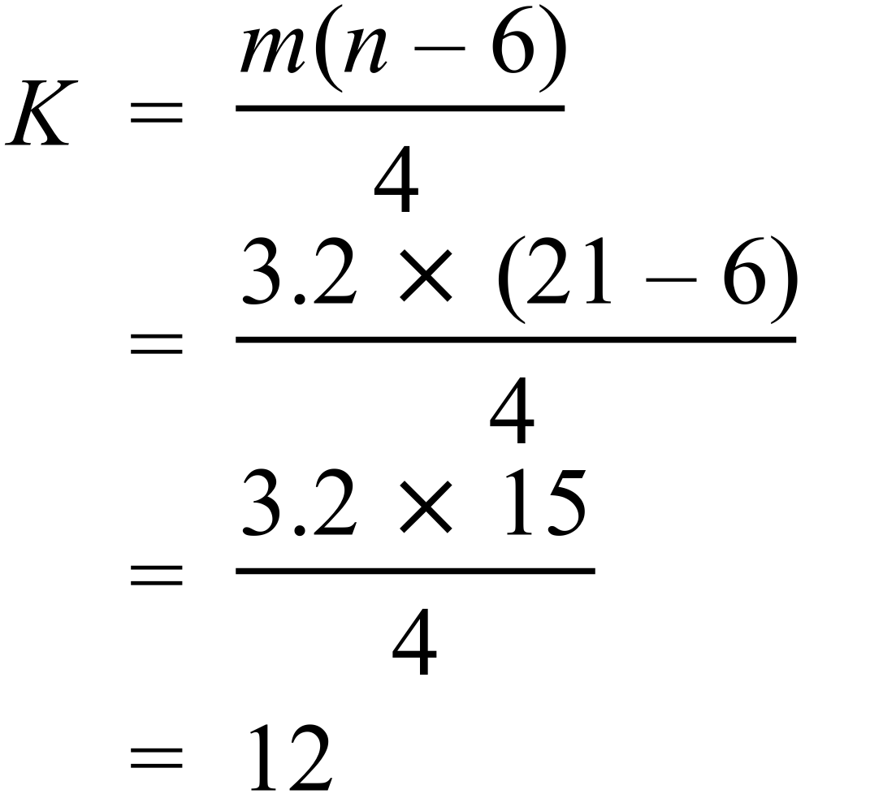 |  |  | D
 |  |  |  | D
 | 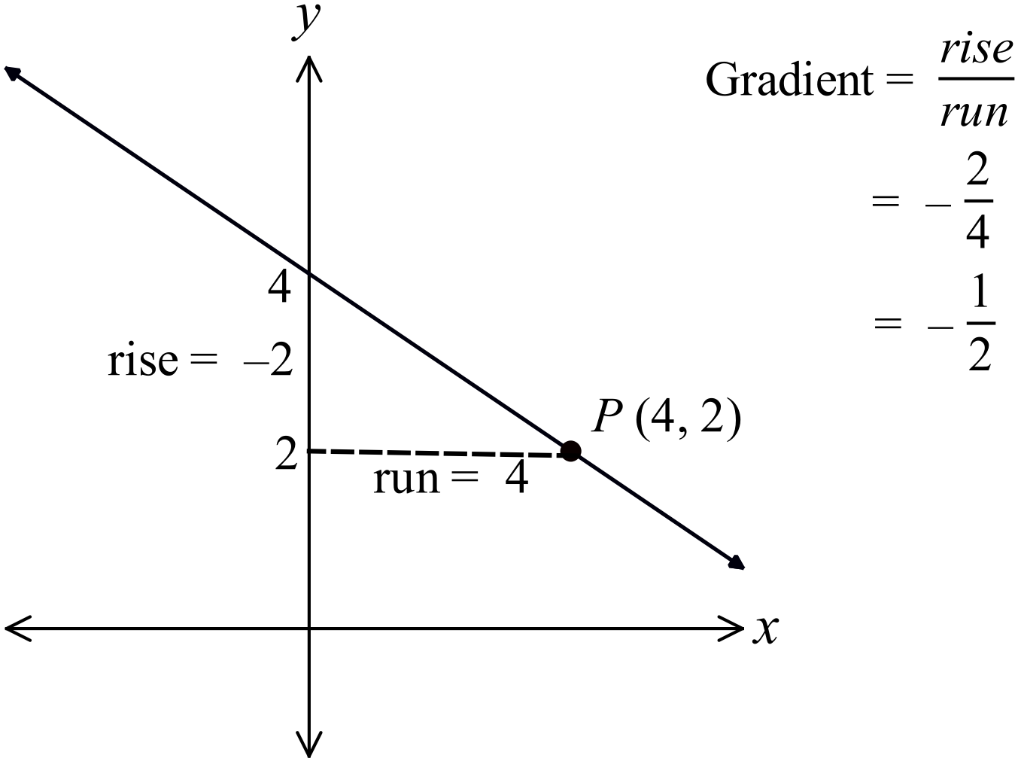 |  |  | C
 | Line 1 has an error  In expanding |  |  | A
 | Splendid Snips distribution has more scores toward the lower values, so it is skewed (positively), while Cute cuts is evenly distributed about the centre, so is symmetrical. |  |  | D
 | Both distributions have 22 data points, so the middle scores are the 11th and 12th scores.  Median Splendid Snips = 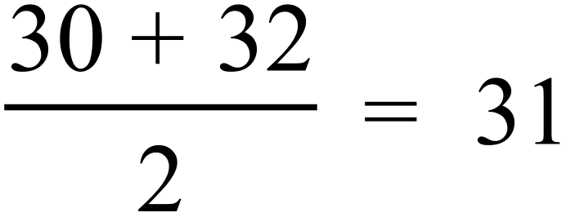  Median Cute Cuts = 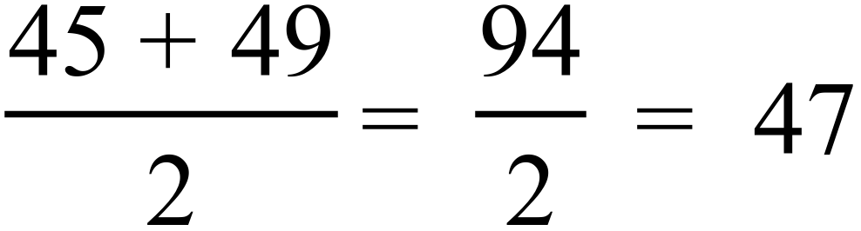  Difference = 47 – 31 = 16 |  |  | C
 | Total number of people = 4 + 14 + 9 + 24 + 30 + 24  = 105  Number of dwellings = 4 + 7 + 3 + 6 + 6 + 4 = 30  Average = 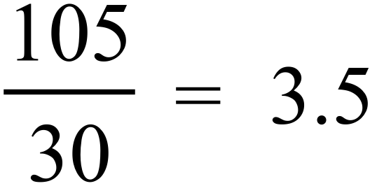 |  |  | B
 | It was 6º C at around 1:30 am, 6:00 am and at about 6:30 pm. |  |  | B
 | 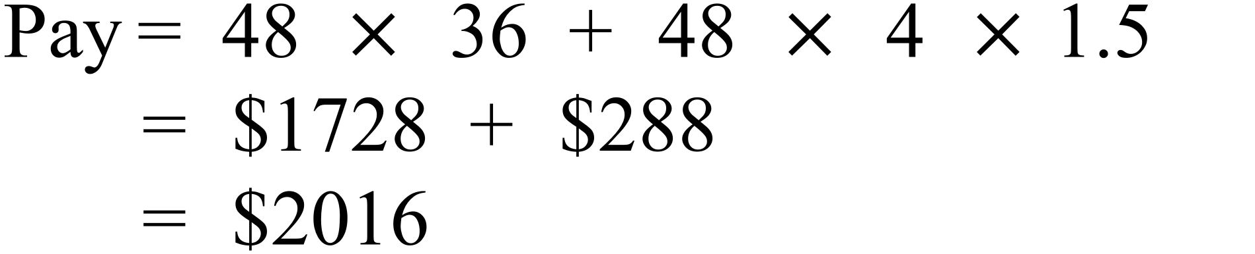 |  |  | C
 | 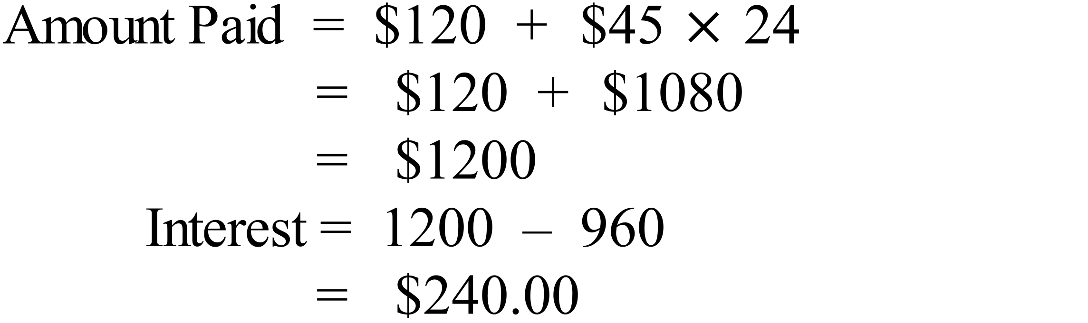 |  |  | B
 | 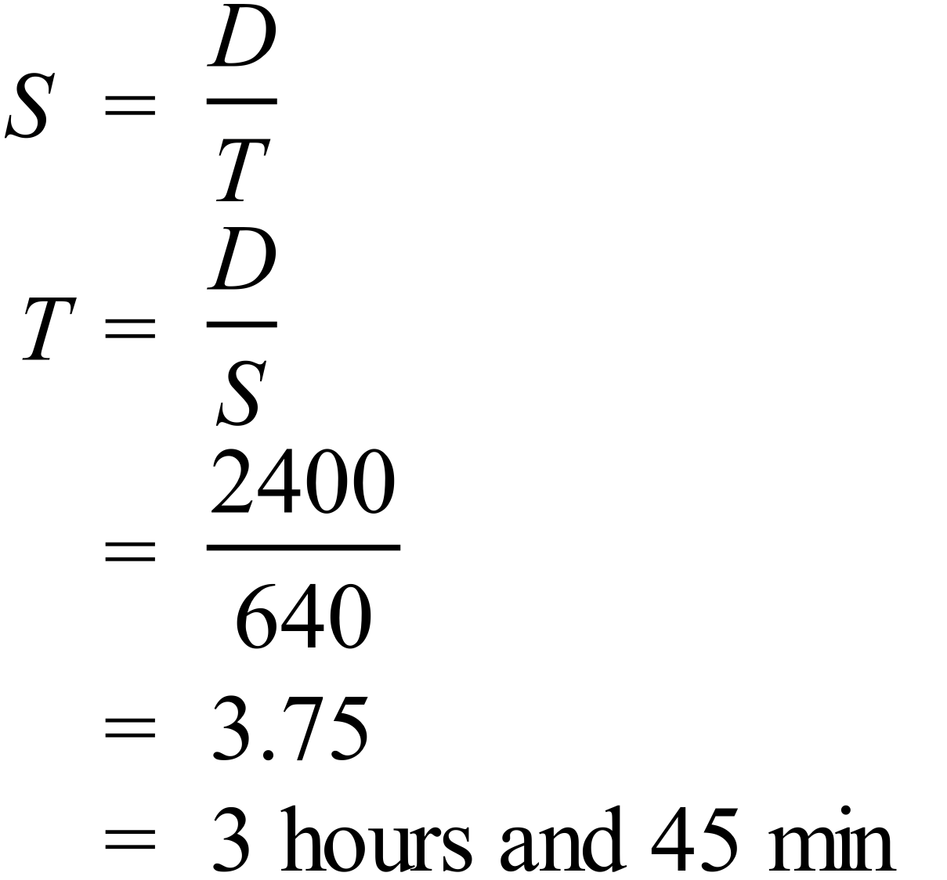 |  |  | D
 | 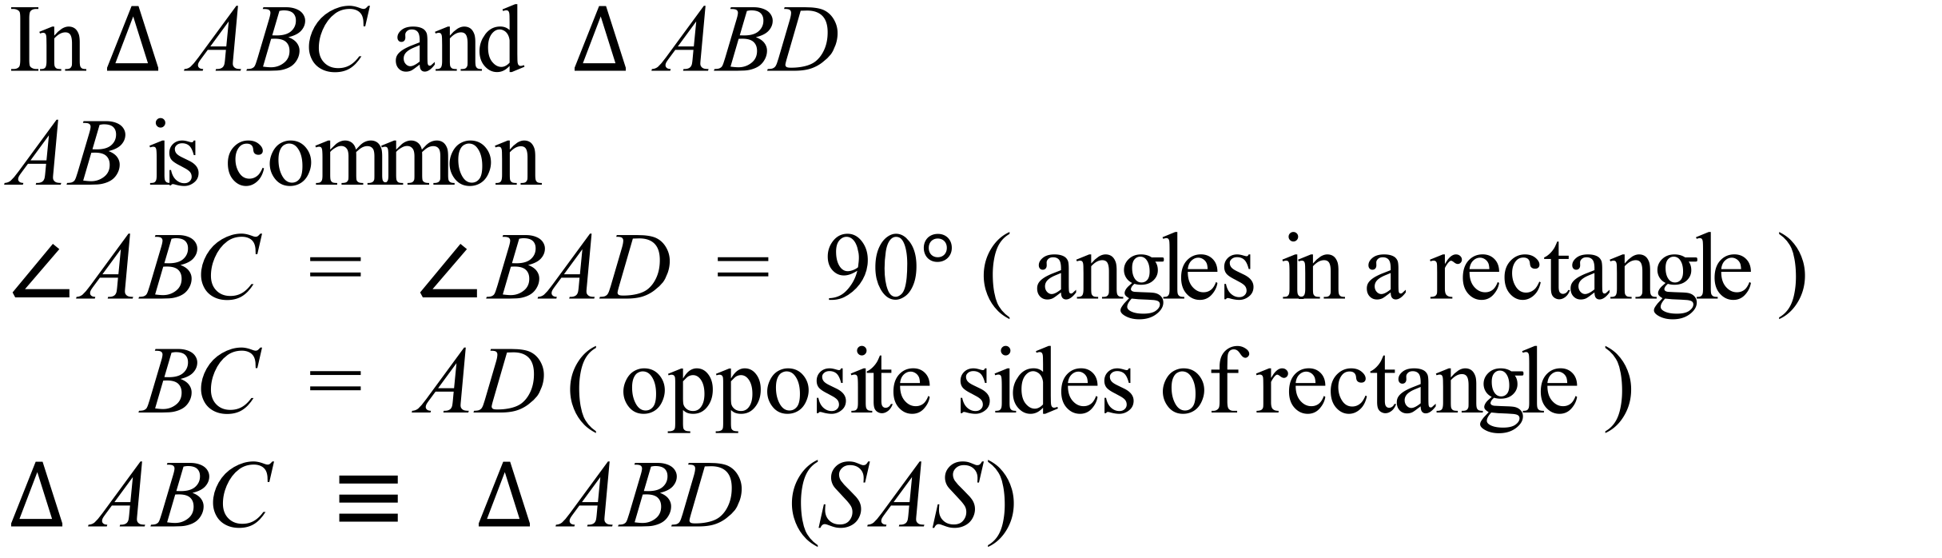 |  |  | C
 | 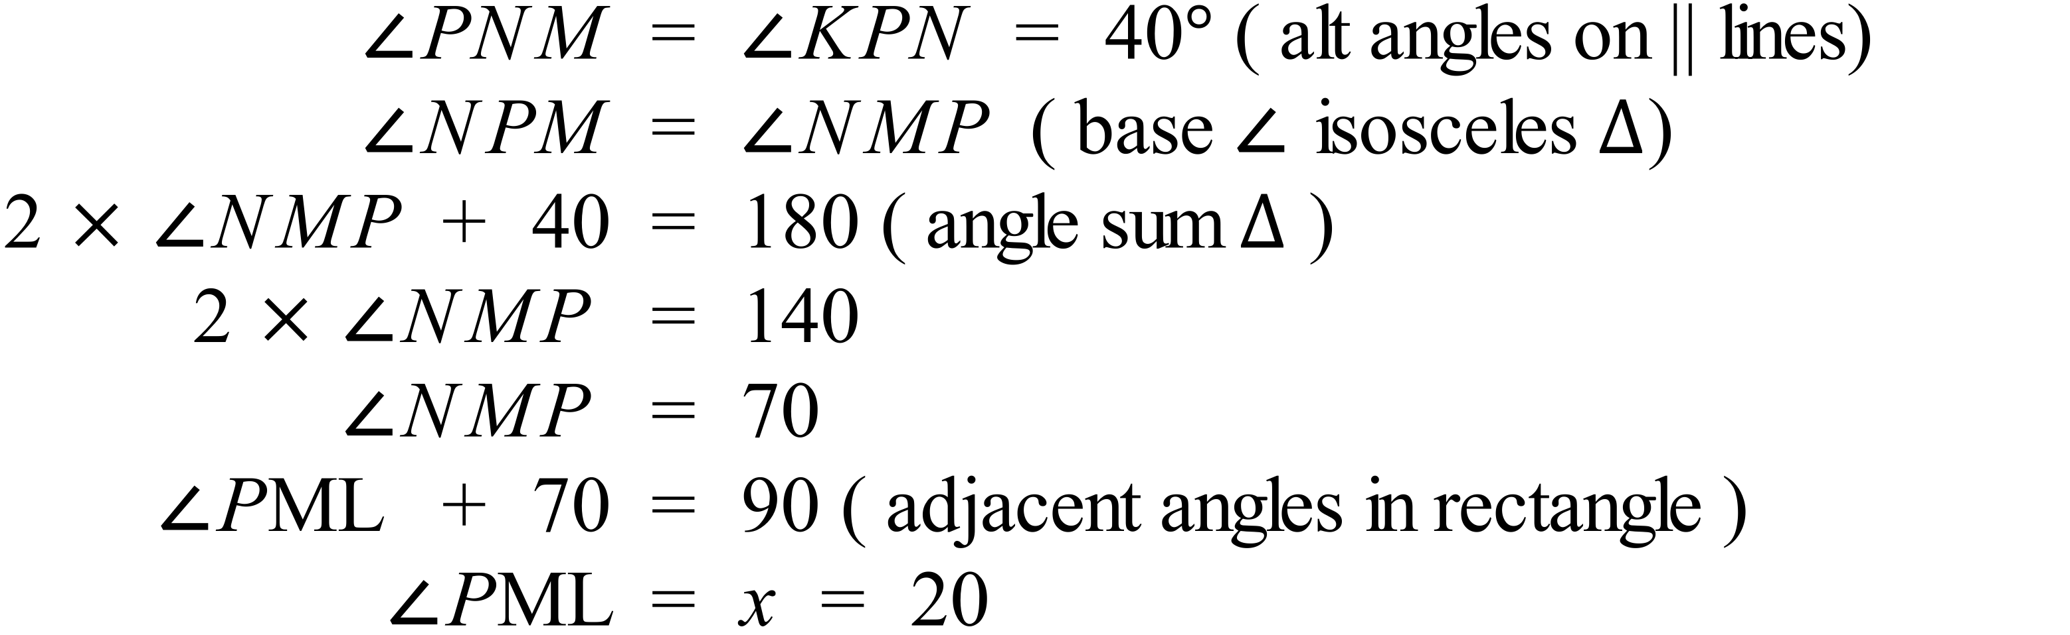 |  |  | A
 | 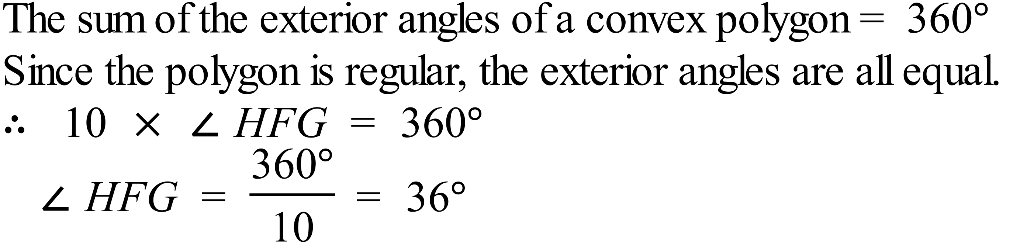 |  |  | C
 | 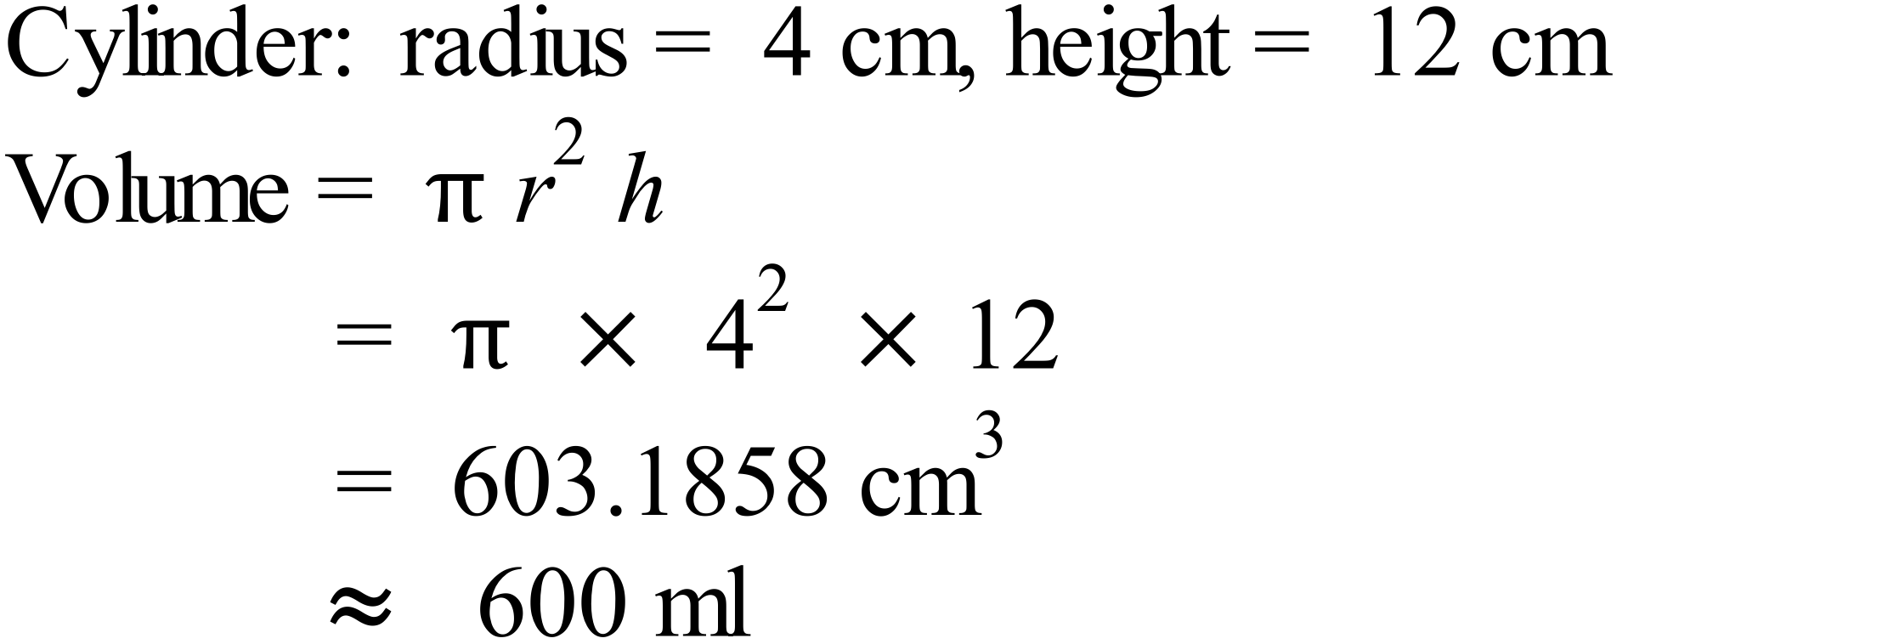 |  |  | B
 | 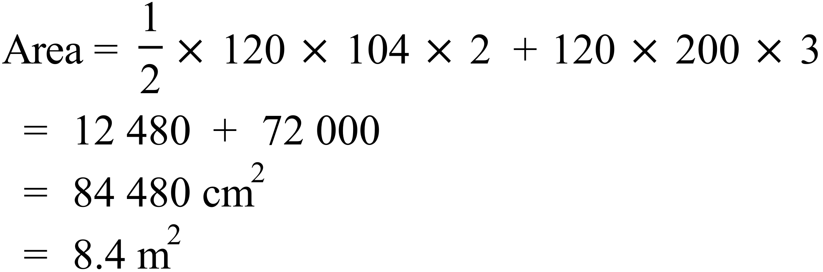 |  |  | D
 | 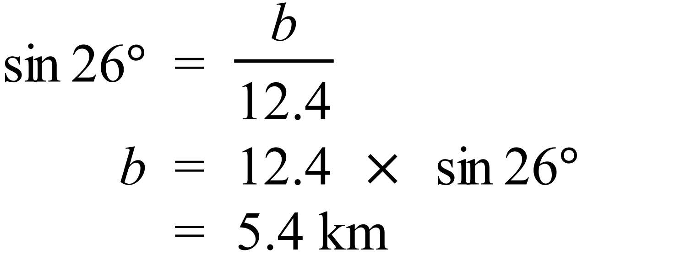 |  |  | A
 | 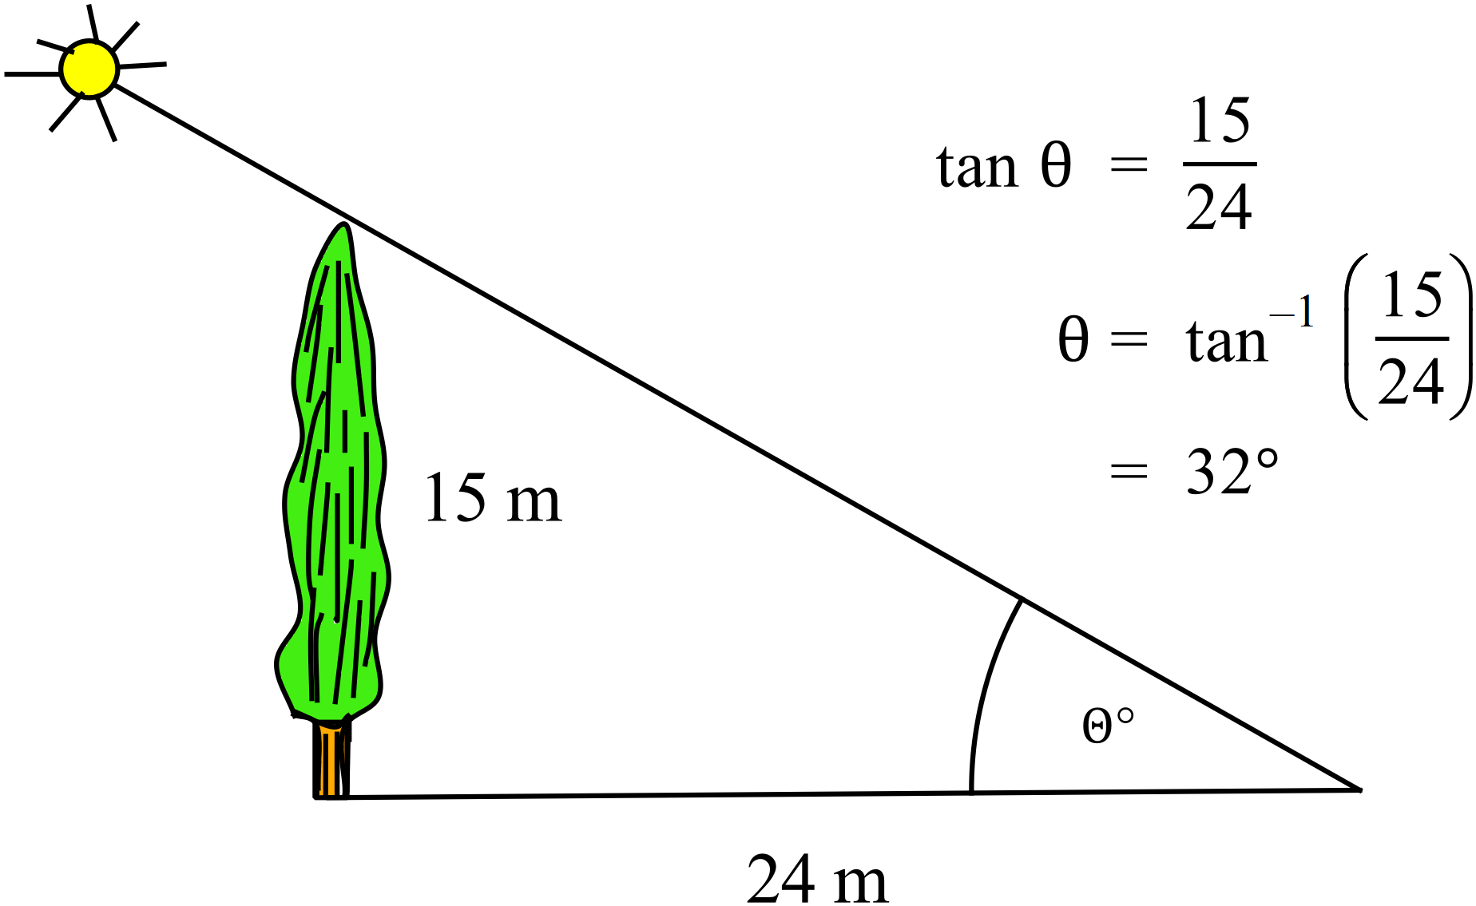 |  |  | A
 | 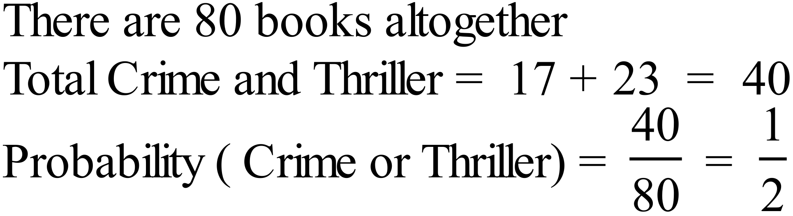 |  |  | C
 |  |  |  | B
 | 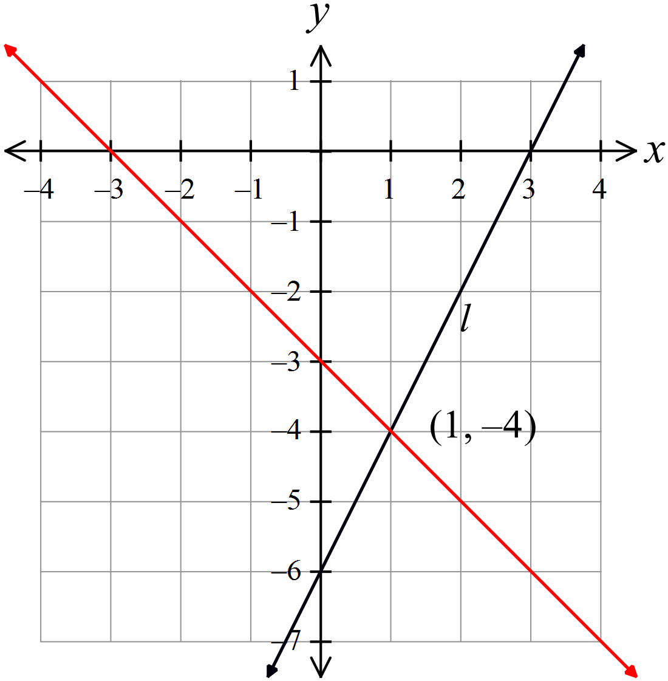  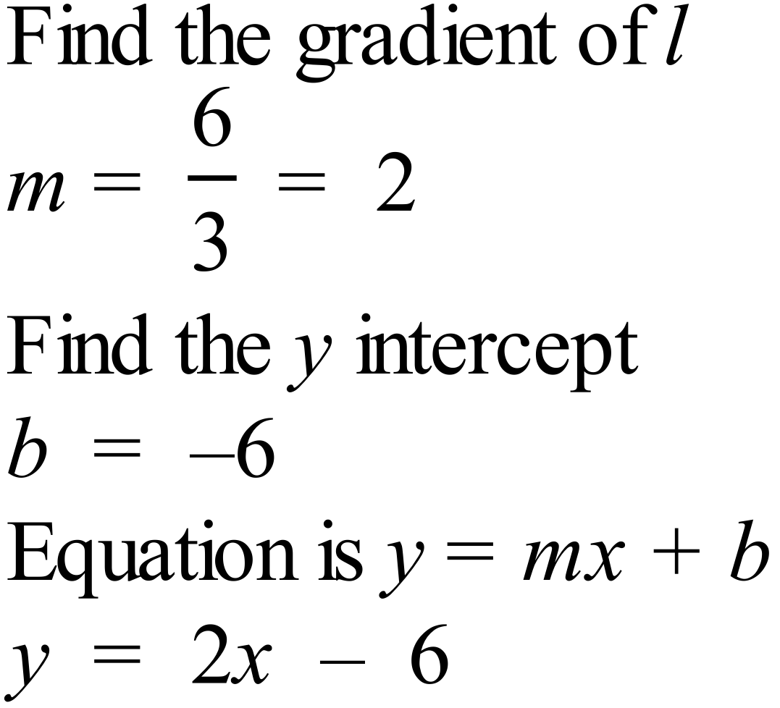 |  |  | D
 | Draw the graph of 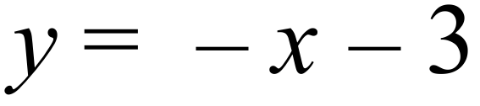  y-intercept = -3, so mark -3 on y axis  Gradient = -1, so go across 1 and down 1 to obtain a second point, and draw the line as shown on graph above.  Point of intersection is (1, -4) |  |  | B
 | 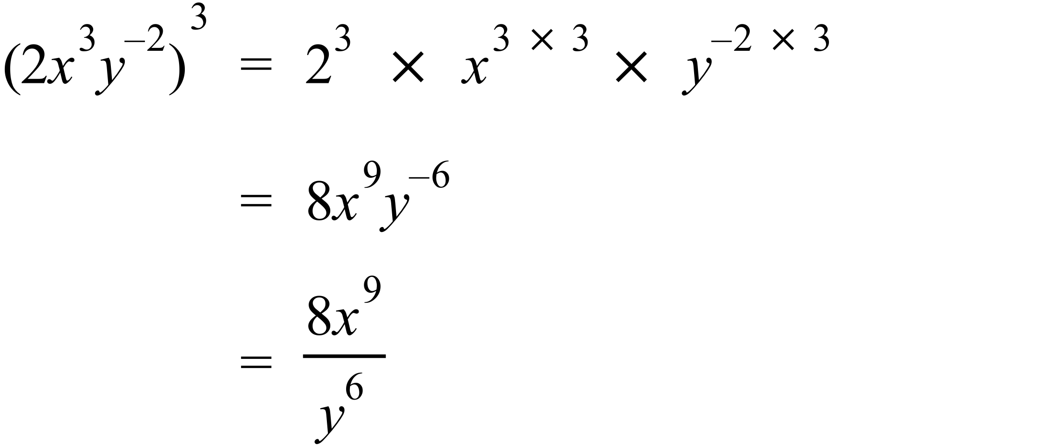 |  |  | B
 | Open circle on -3 indicate 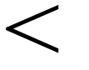 and closed on 2 indicates   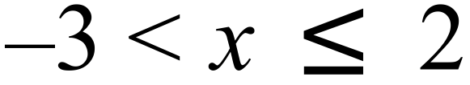 |  |  | A
 | It is bimodal as two scores occurred four times which is more than any other score. |  |  | A
 | Median = average of 9th and 10th scores = 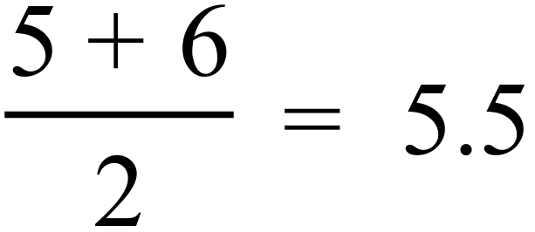  Mean = 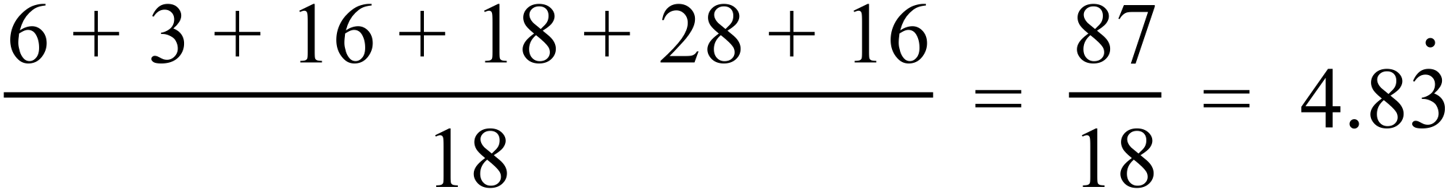  Mode = 4 and 7  Range is from 2 to 8, ie 6  Statement D is inaccurate as the most common (mode) is both 4 and 7, not just 7. |  |  | D
 | There are 18 data scores altogether, and 4 of these represent groups of four.  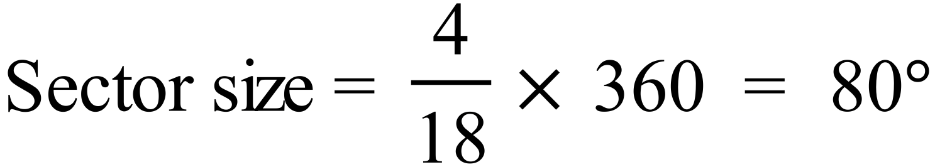 |  |  | D
 | Mean : Since two scores greater than the mean are added, the mean will change.  Median: Since the mode is 14 with 3 scores, and the median is 11, the most number of 11’s possible is 2. Since there were an even number of scores, the median came from two 11’s or two other scores with an average of 11. When two scores greater than 11 are added, the median will move to the right, and hence will change.  Mode: Mode is 14 which occurs 3 times, and since the highest score is 9 (minimum) + 6 (range) = 15 there were no 16’s previously, so now there are two 16’s, so 14 remains the mode.  Range : The range was 6, going from 9 to 15, so adding 2 16’s makes it 7, so it changes.  Only the mode doesn’t change. |  |  | C

School Name
Year 10 Half Yearly Examination
Mathematics Course 2016
Multiple Choice Section Answer Sheet

Name ________________________________ Teacher ________________________

Completely fill the response oval representing the most correct answer.
Use a black or blue pen or 2B pencil.

21. A B C D
22. A B C D
23. A B C D
24. A B C D
25. A B C D
26. A B C D
27. A B C D
28. A B C D
29. A B C D
30. A B C D
31. A B C D
32. A B C D
33. A B C D
34. A B C D
35. A B C D
36. A B C D
37. A B C D
38. A B C D
39. A B C D
40. A B C D

41. A B C D
42. A B C D
43. A B C D
44. A B C D
45. A B C D
46. A B C D
47. A B C D
48. A B C D
49. A B C D
50. A B C D
51. A B C D
52. A B C D
53. A B C D
54. A B C D
55. A B C D
56. A B C D
57. A B C D
58. A B C D
59. A B C D
60. A B C D

School Name  Half Yearly Examination | Mathematics Course  2016
Section 2  Part B  Longer Answer Section | WME Solutions
61. |  | 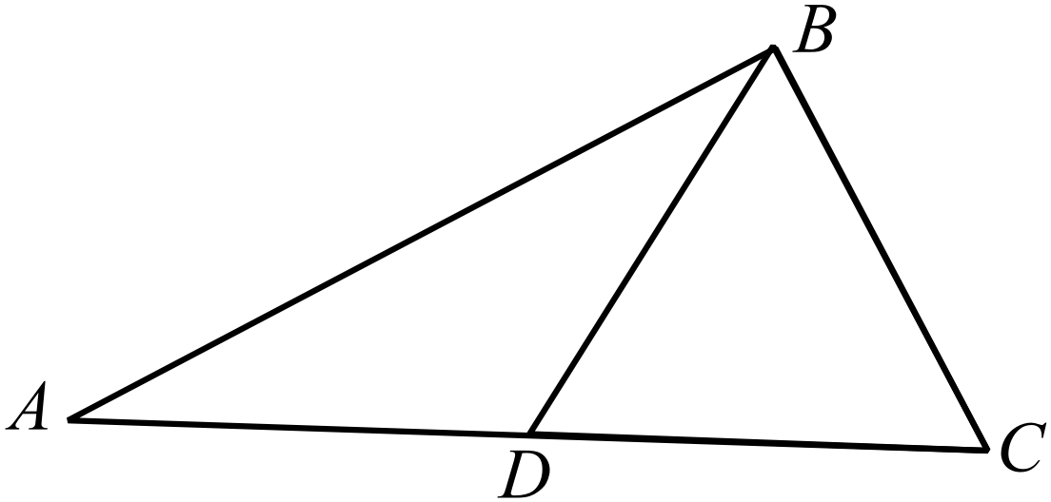  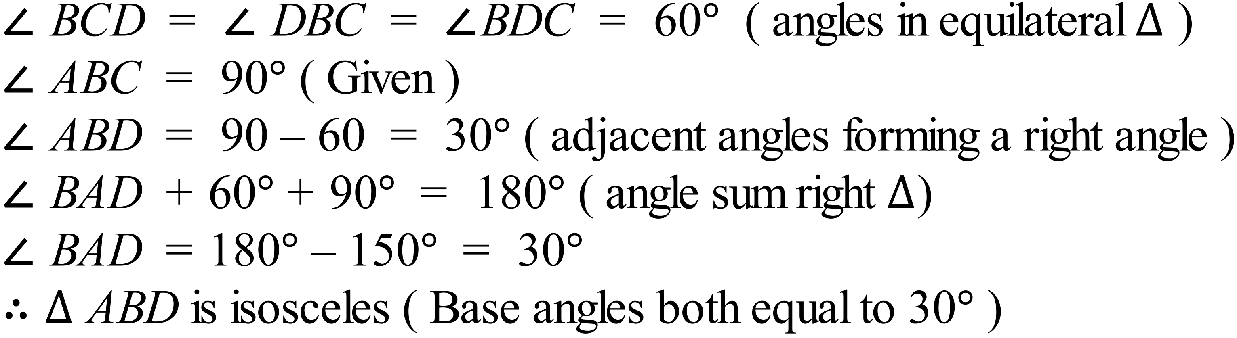 | 2 marks for any complete proof or explanation which logically shows that the base angles are equal.  1 mark for any proof or explanation which finds at least two of the relevant angles in the triangles, but is not complete.
62. | a) | 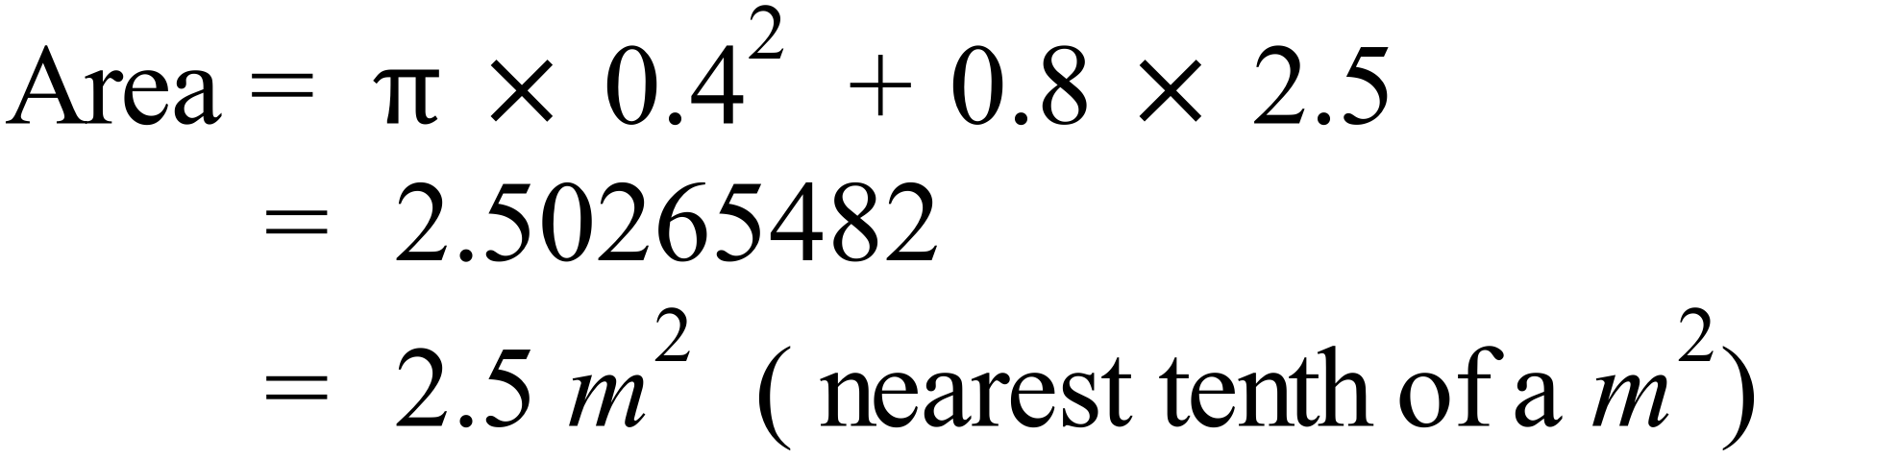 | 1 mark for correct answer.
 | b) | 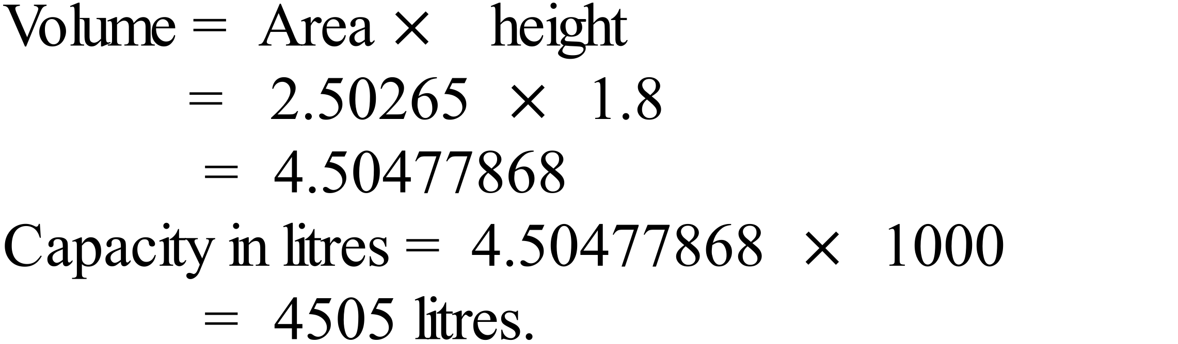 | 1 mark for correct answer.
63. | a) | 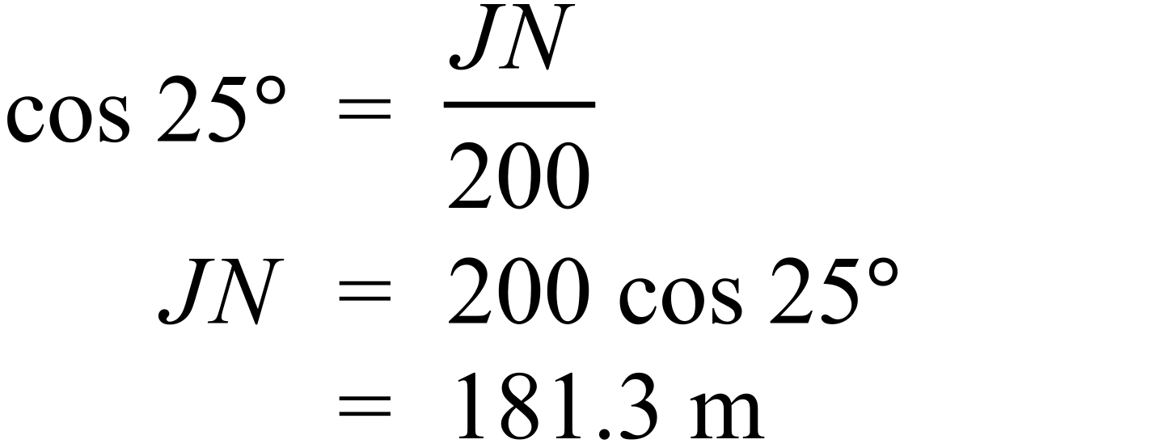 | 1 mark for correct answer.
 | b) | 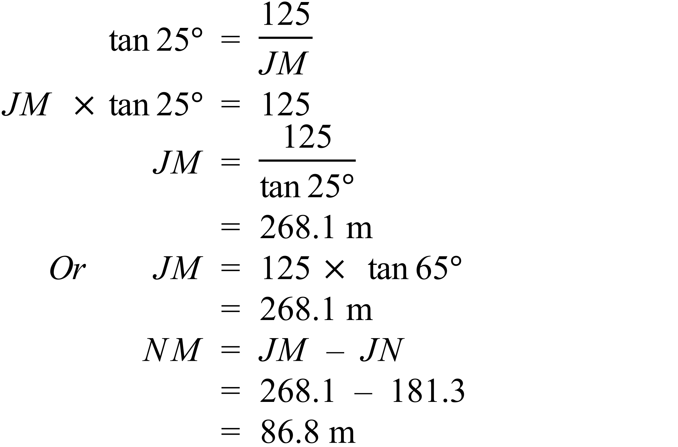 | 2 marks for the correct answer, or an answer calculated correctly from part a)  1 mark for an incorrect or incomplete answer which has some correct working
64. | a) | 40 people out of 60 would recommend the movie.  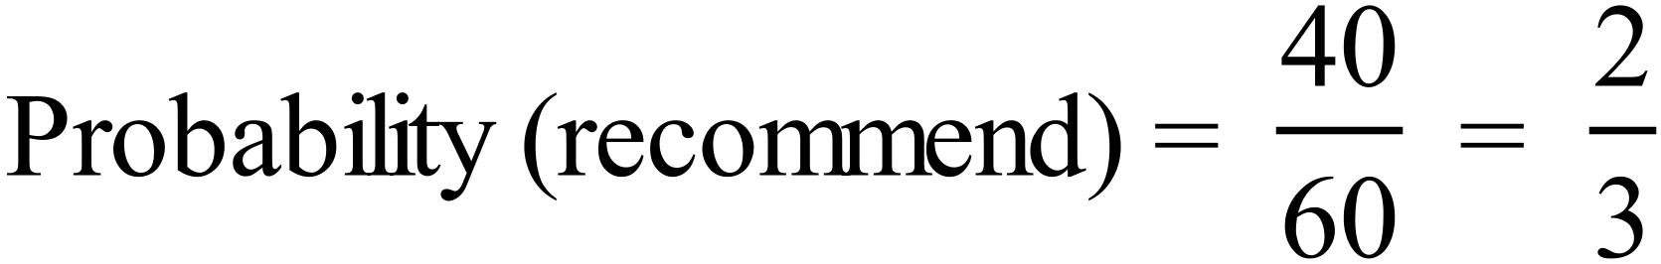 | 1 mark for correct answer
 | b) | 6 males would not recommend the movie.  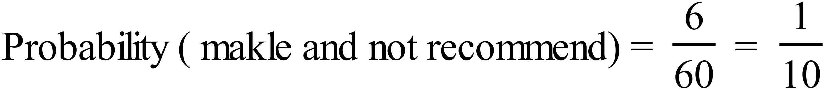 | 1 mark for correct answer
 | c) | If person is male  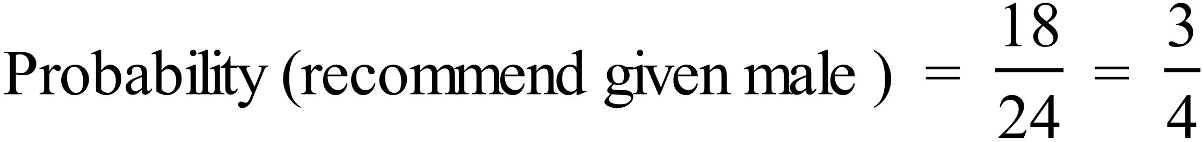  If person is female  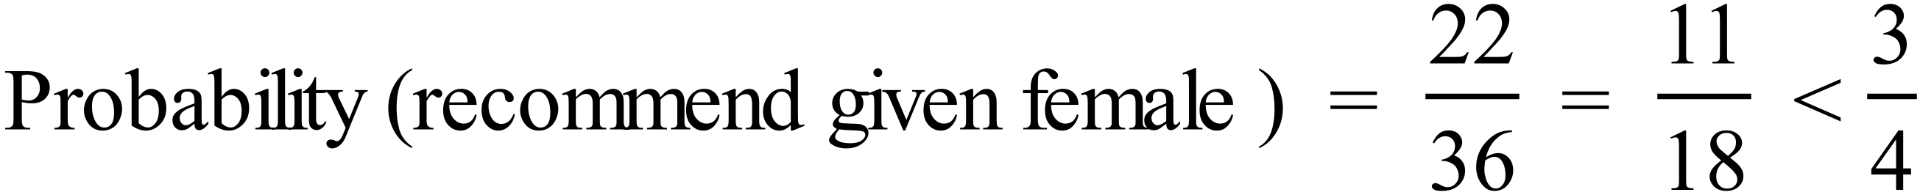  A male is more likely to recommend the movie. | 1 mark for correct explanation
65. | a) | 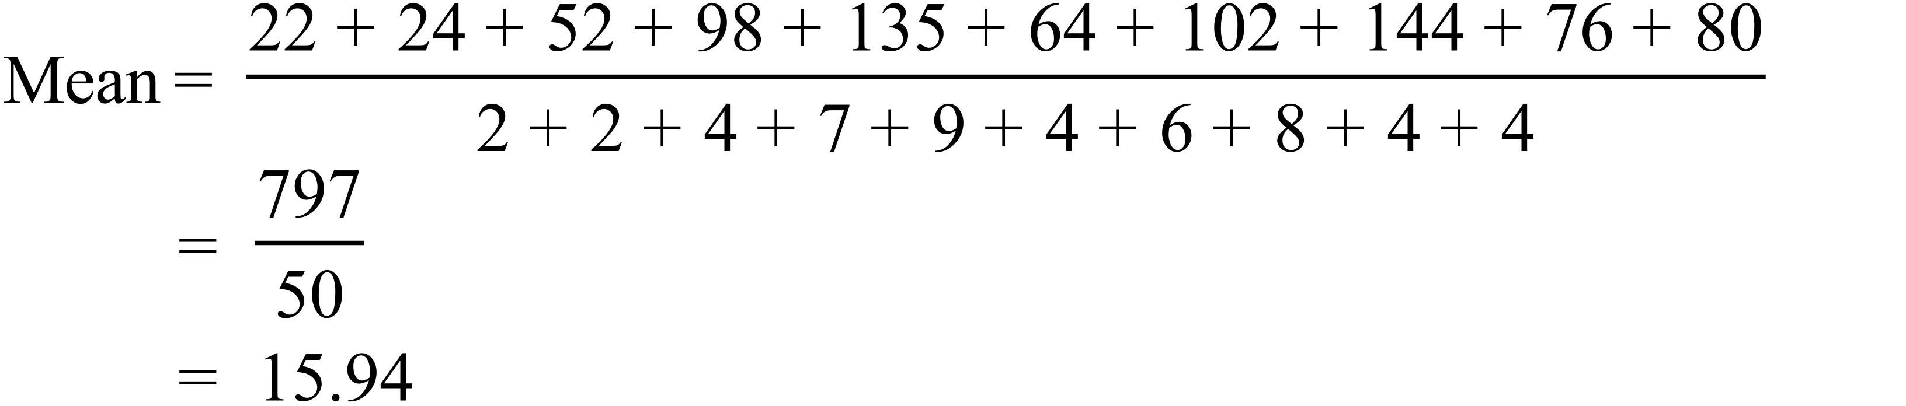 | 1 mark for correct answer
 | b) | Median is the average of the 25th and 26th scores  Both of these are 16, so Median = 16. | 1 mark for correct answer
 | c) | 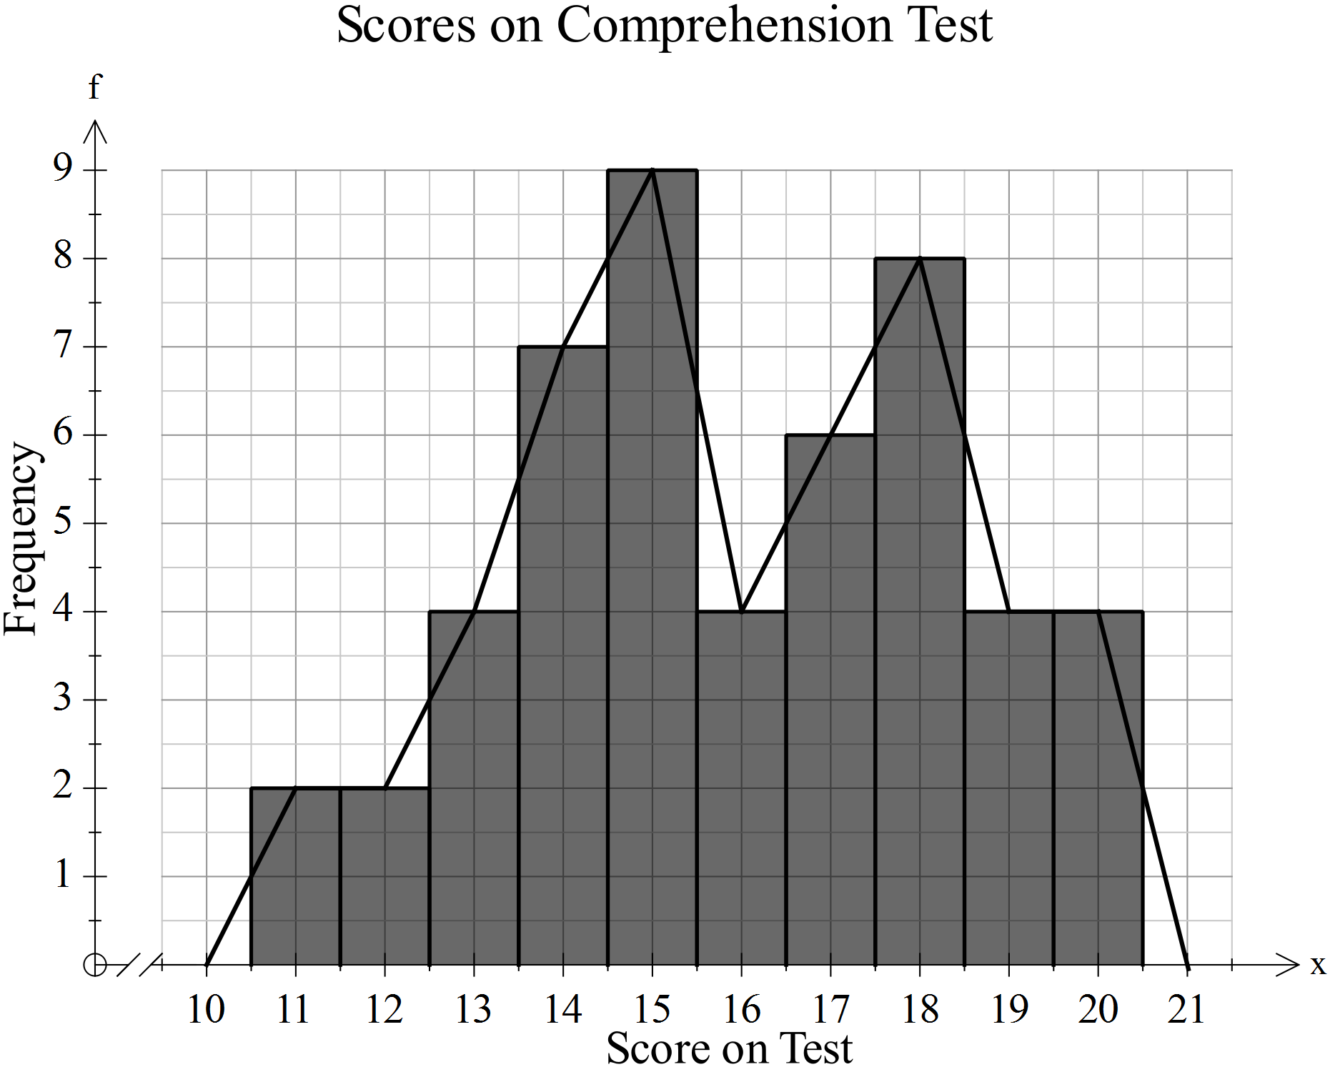 | 1 mark for correct line graph added to the diagram.
66. | a) | 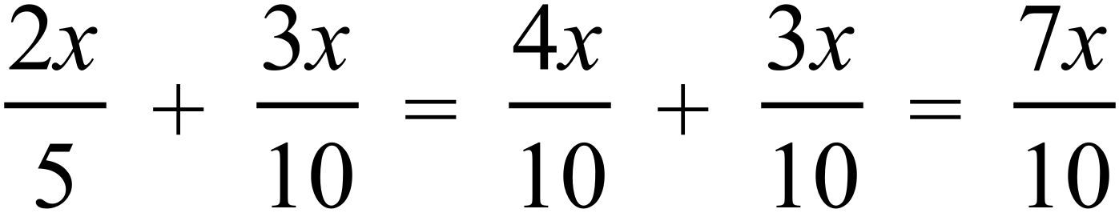 | 1 mark for correct answer
 | b) | 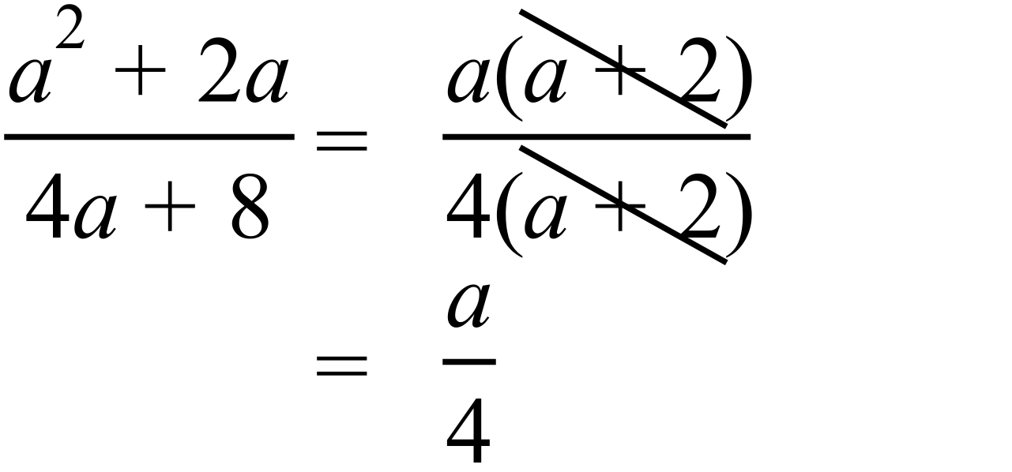 | 1 mark for correct answer
67. |  | 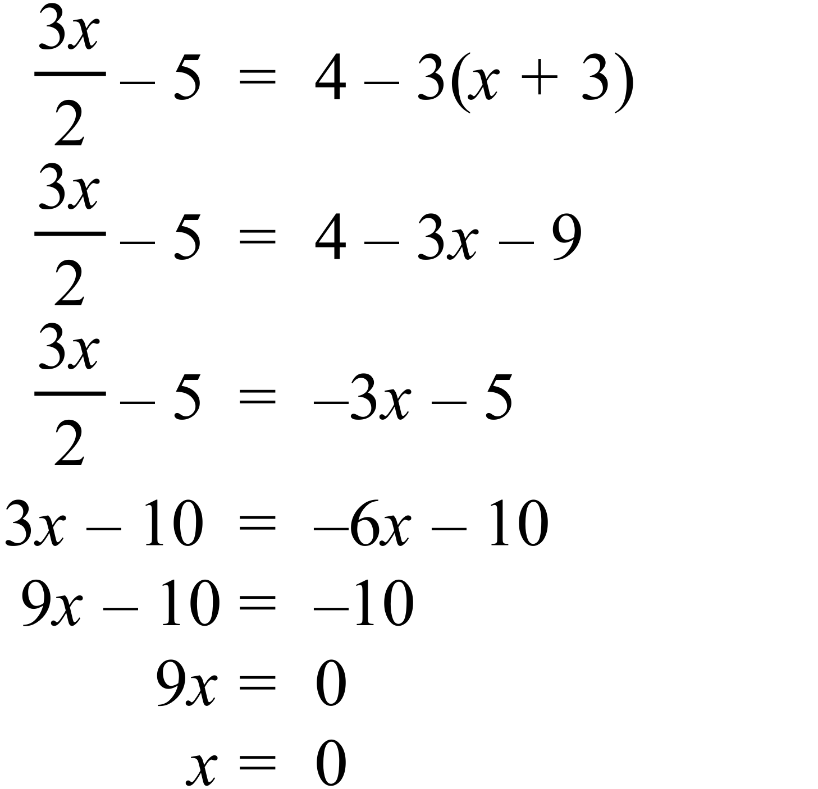 | 2 marks for correct solution.  1 mark for a solution with a minor error in reasoning or calculation.
68. |  | 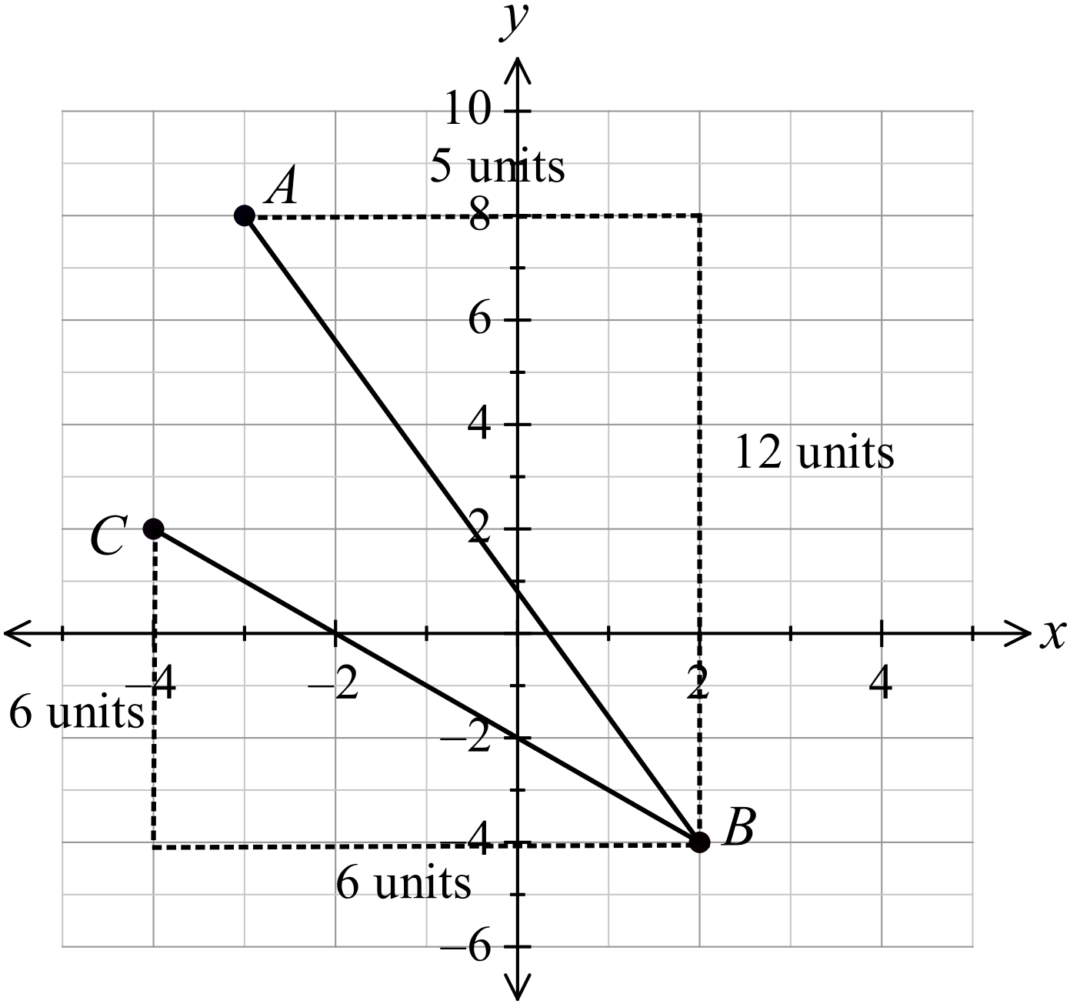
 | a) | 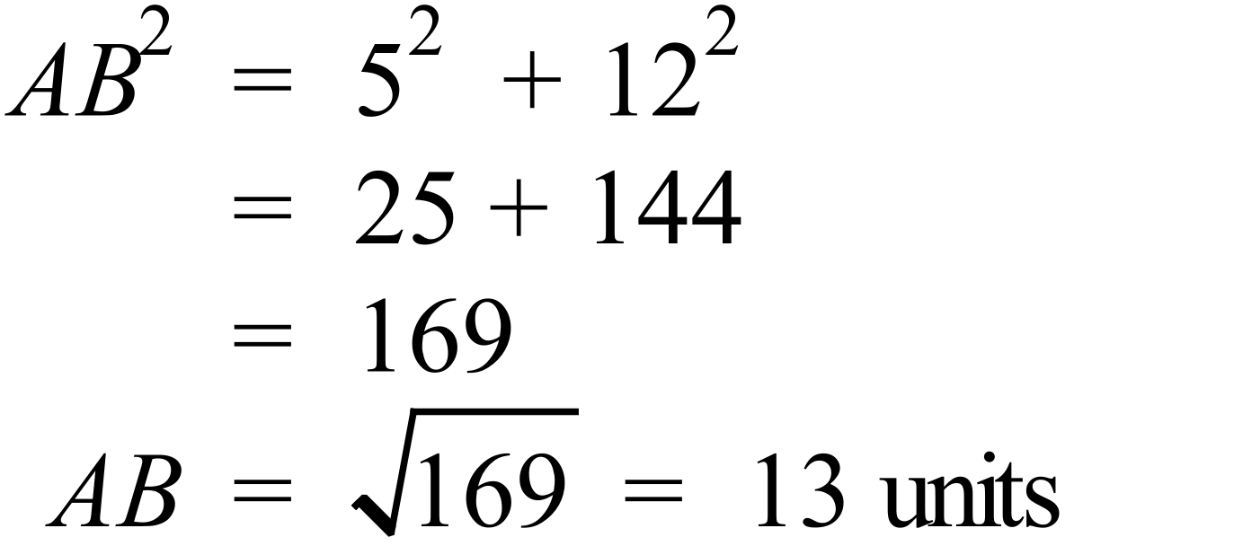 OR 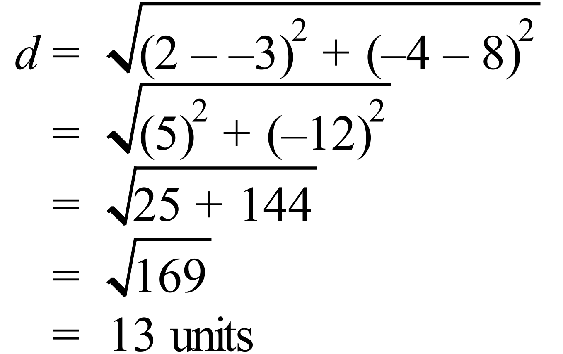 | 1 mark for correct answer
 | b) | 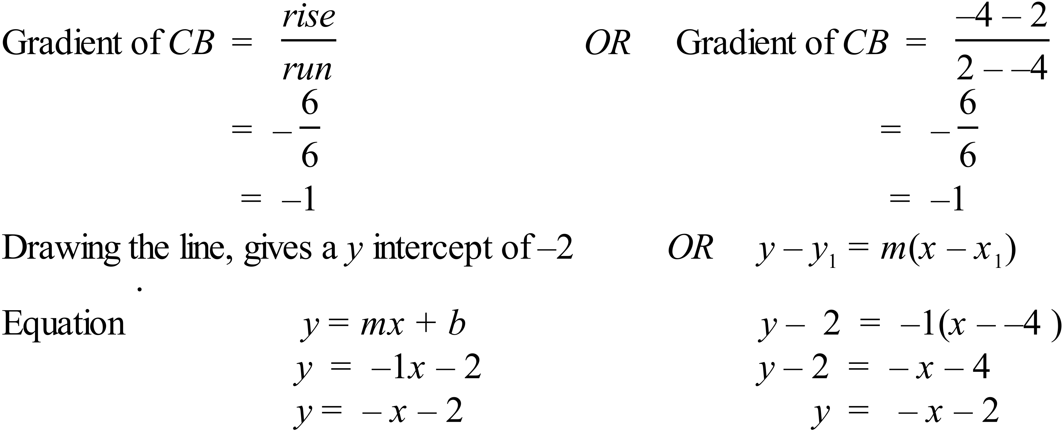 | 2 marks for correct equation.  1 mark for a working which has a minor error in reasoning or calculation, or which is incomplete, (e.g., finding the gradient only).

